**MAJOR PROJECT**

**1. Executive Summary**

**1.1 Project Overview**

To develop the System to analyze the log data (In XML format) of government progress of various development activities.

**1.2 Purpose and Scope of this Specification**

The purpose of this project is to capture the data for analyzing the progress of various activities.

In scope The following requirement will be addressed in phase 1 of Project:

• Developing system to handle the incoming log feed and store the information in Hadoop Cluster (Flume)

• Analyze the data and understand the progress

• Store the results in Hbase/RDBMS Out of scope We can use this data and visualization and get more insights

**2. Product/Service Description**

2.1 Assumptions Log will be generated in XML format and stored in a server

2.2 Constraints Describe any item that will constrain the design options, including

• This system may not be used for searching for now. But it will be used for analysis and saving the relevant information as of now

• System will be using Hbase as a database

**3. Requirements**

• The FLUME job which will format the data and place the data to HDFS

• Pig/MapReduce job for parsing the XML data.

• Create Pig scripts/MapReduce jobs to analyze the data

• Create the Sqoop job to store the data in database Priority Definitions The following definitions are intended as a guideline to prioritize requirements.

• Priority 1 – Create FLUME job for fetching log files from spool directory the data

• Priority 2 – MapReduce/pig job to preprocess Download the dataset using the below link:

**Link-** <https://drive.google.com/file/d/0Bxr27gVaXO5sUjd2RWFQS3hQQUE/view?usp=sharing>

Refer the below steps to understand the actual steps to create the above project.

**Step 1**- Copy dataset from local file system to HDFS using flume.

Note: use the conf file by downloading from below link.

Click here to download Command:

flume-agent agent –n agent1 –c conf –f

**Step 2-**

Input file is in the XML format use Map reduce or pig to parse the data and get the results for the below problem statements.

**4. Problem statement**

1. Find out the districts who achieved 100 percent objective in BPL cards Export the results to mysql using sqoop

2. Write a Pig UDF to filter the districts which have reached 80% of objectives of BPL cards. Export the results to MySQL using Sqoop.

**Solution-**

The given dataset is in XML format.

The dataset is copied from local file system to HDFS using flume.

**Flume Configuration File-**

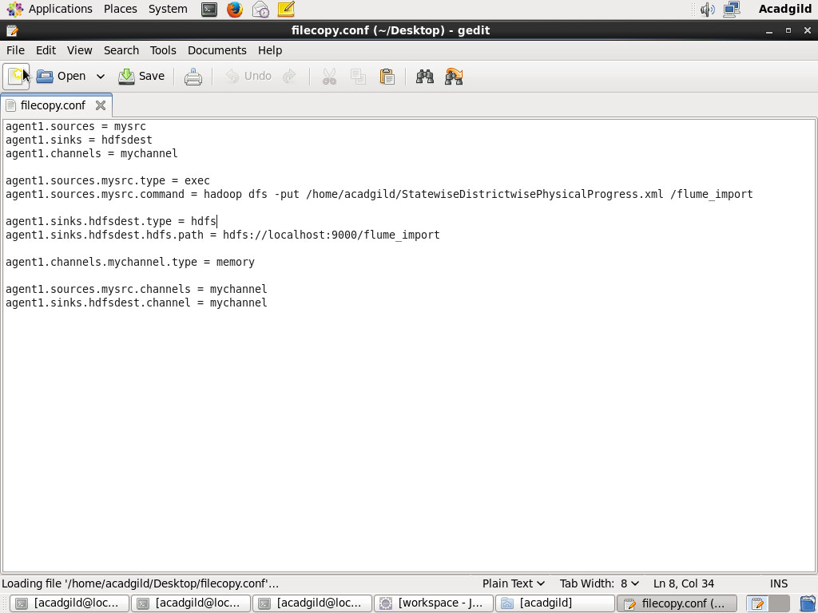

**Creating Output Directory-**

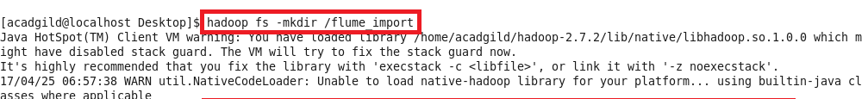

**Listing the directories-**

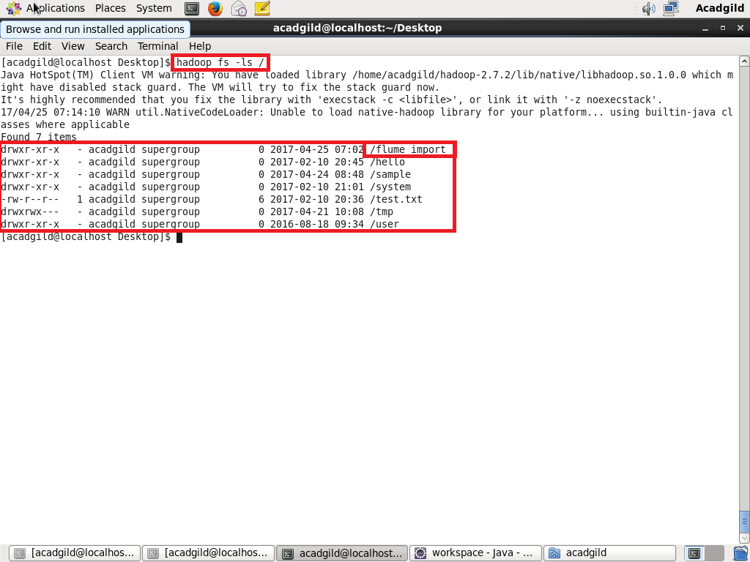

**Running Flume agent-**

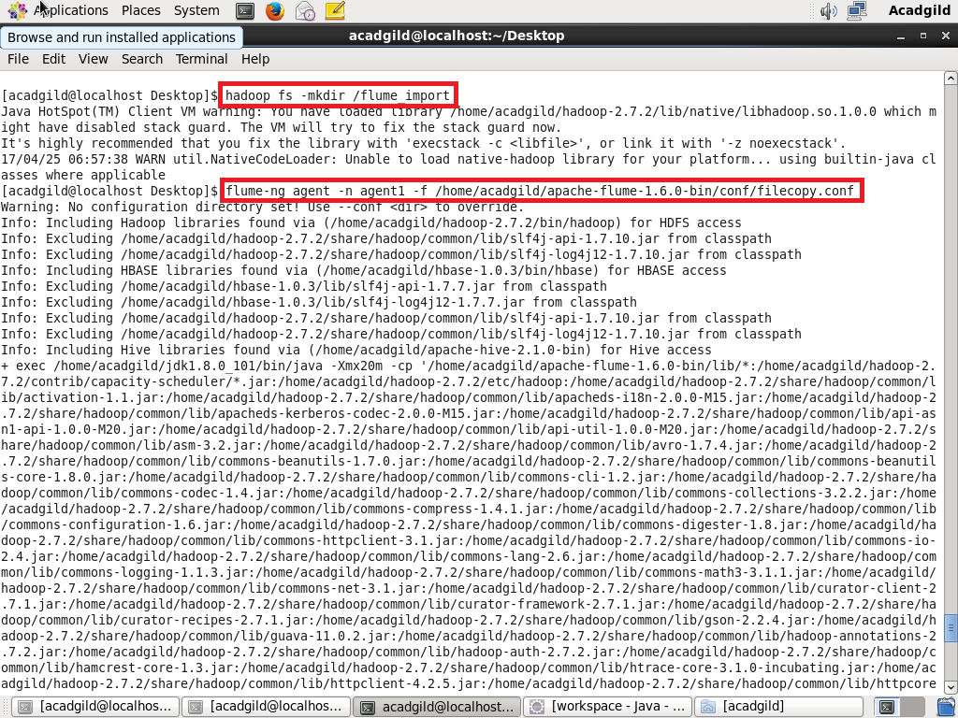

The file is successfully copied to the directory /flume_import

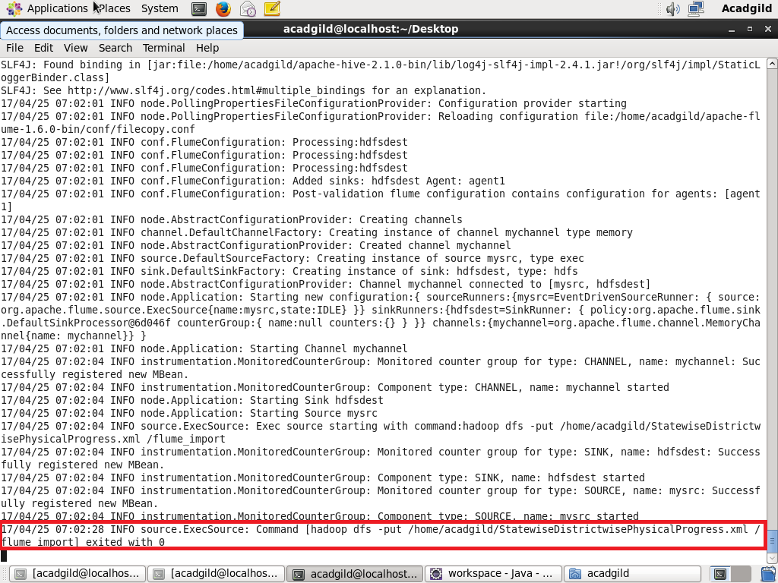

**The Xml file is copied into HDFS**

**Using cat command, displaying the contents of the file.**

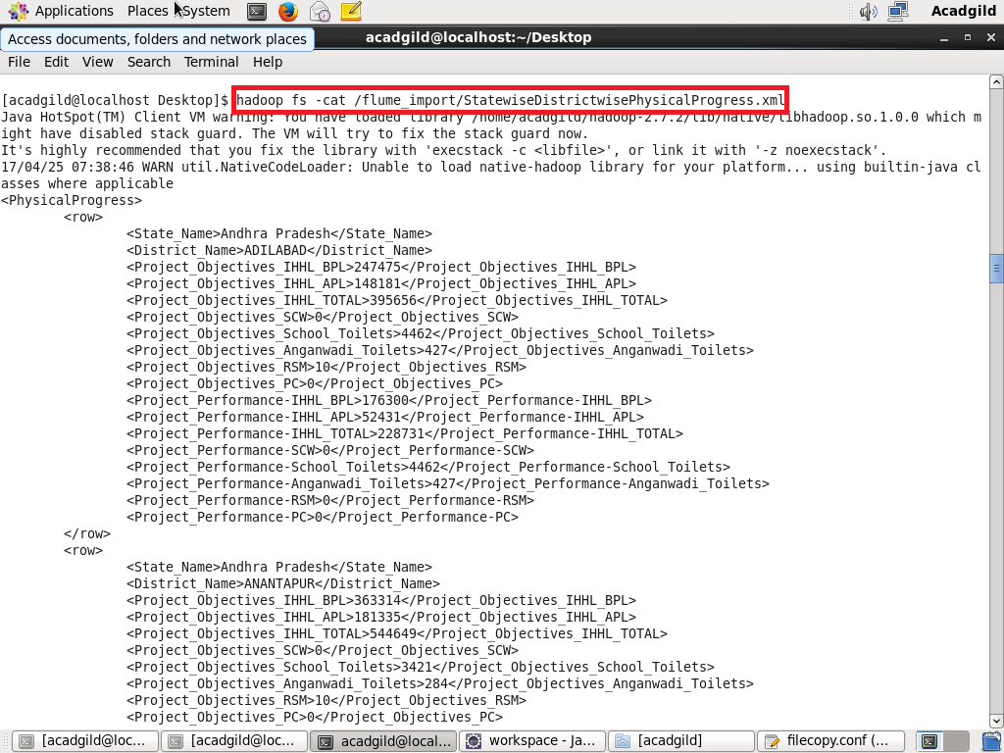

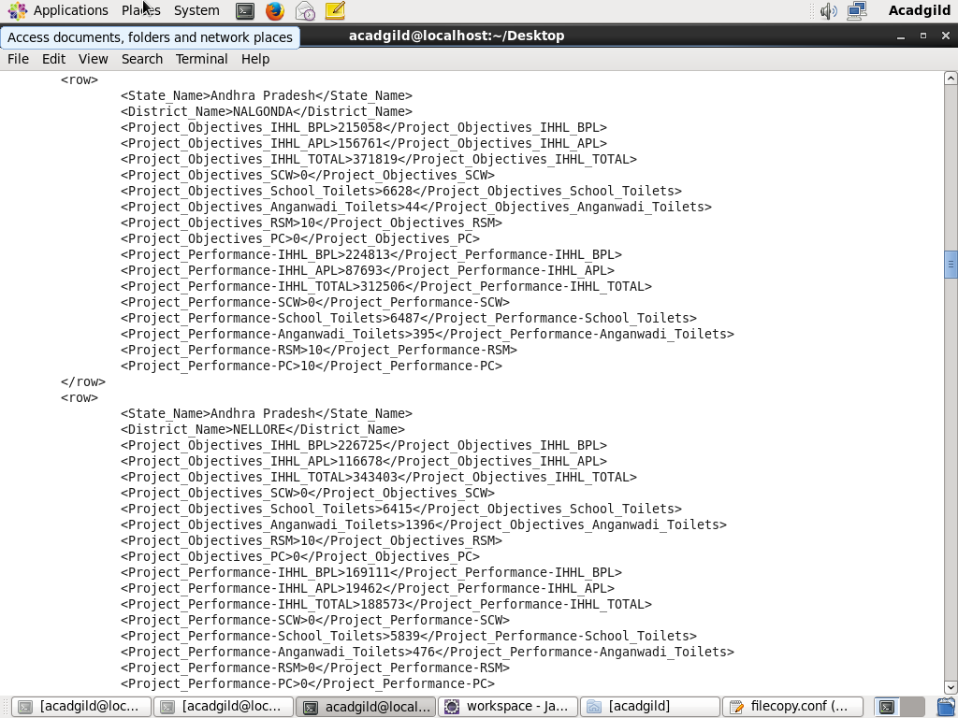

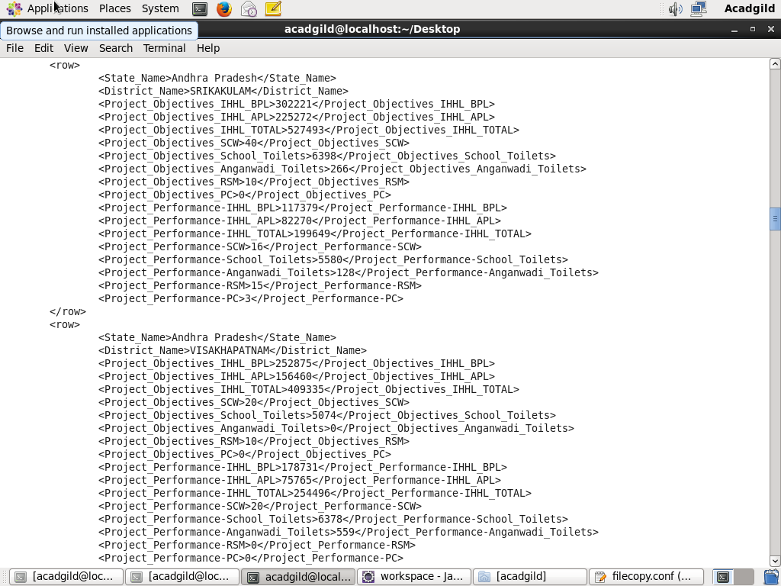

Xml file is successfully copied into the HDFS and the xml file is displayed.

**Now, we have to convert the xml file to csv file using pig script**

**Pig script to convert xml file to csv file-**

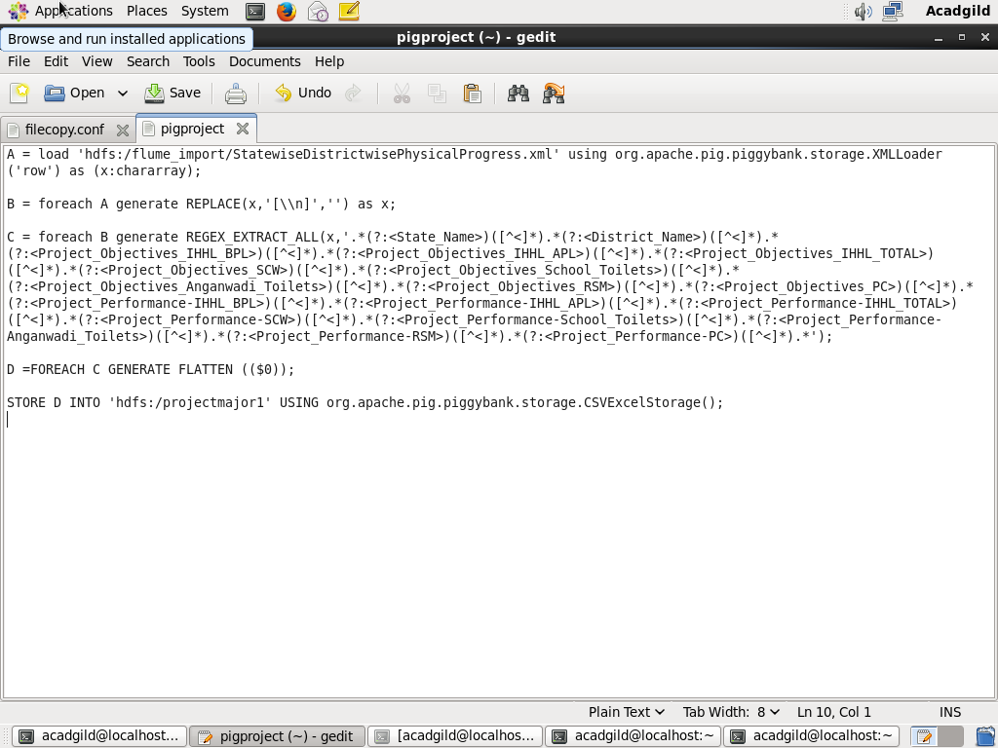

**Executing Pig-**

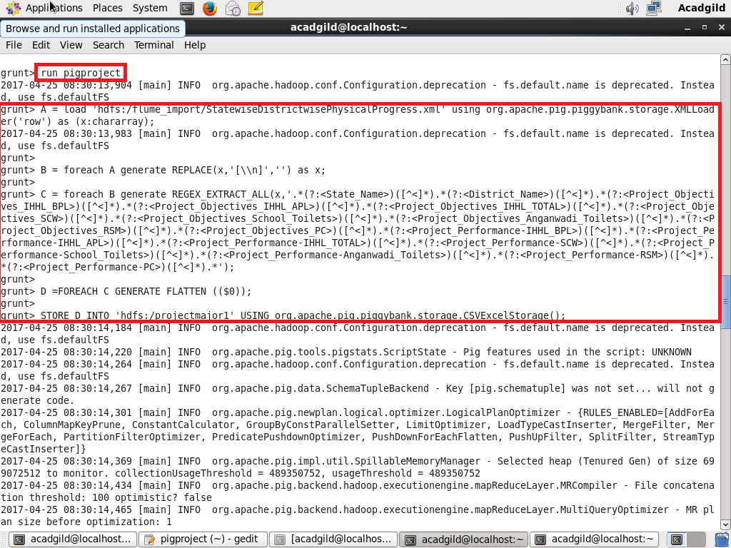

**Successful execution of PIG SCRIPT-**

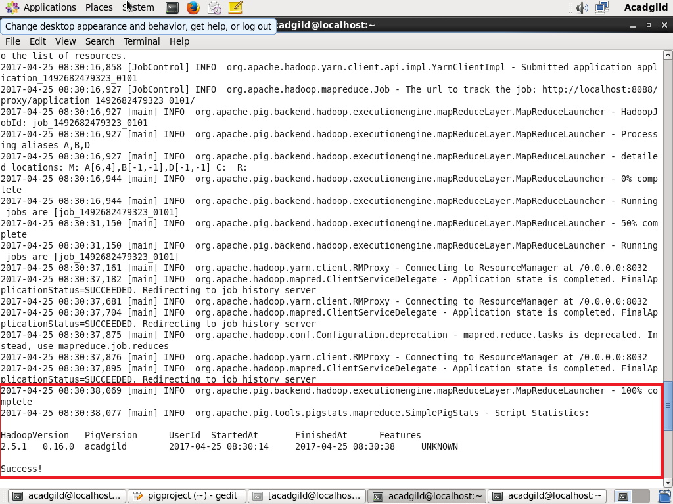

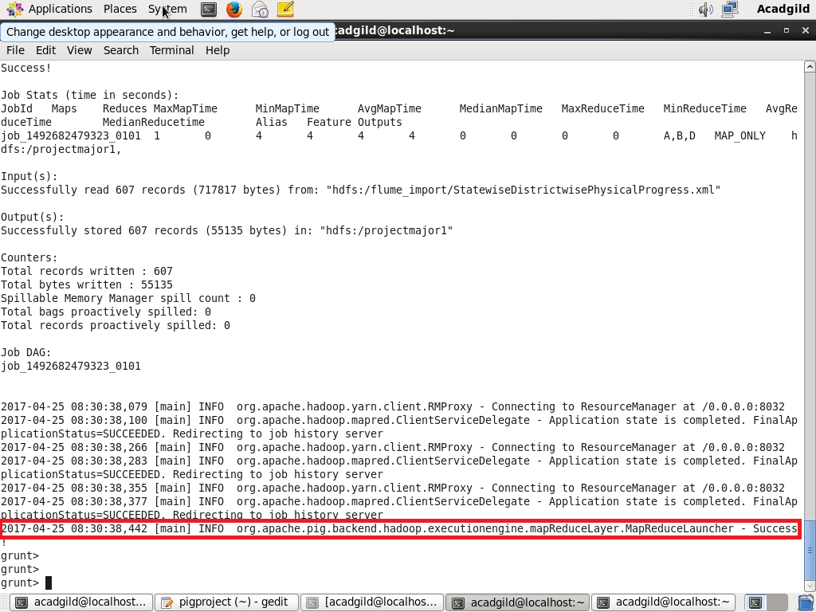

**Displaying the contents of the directory-**

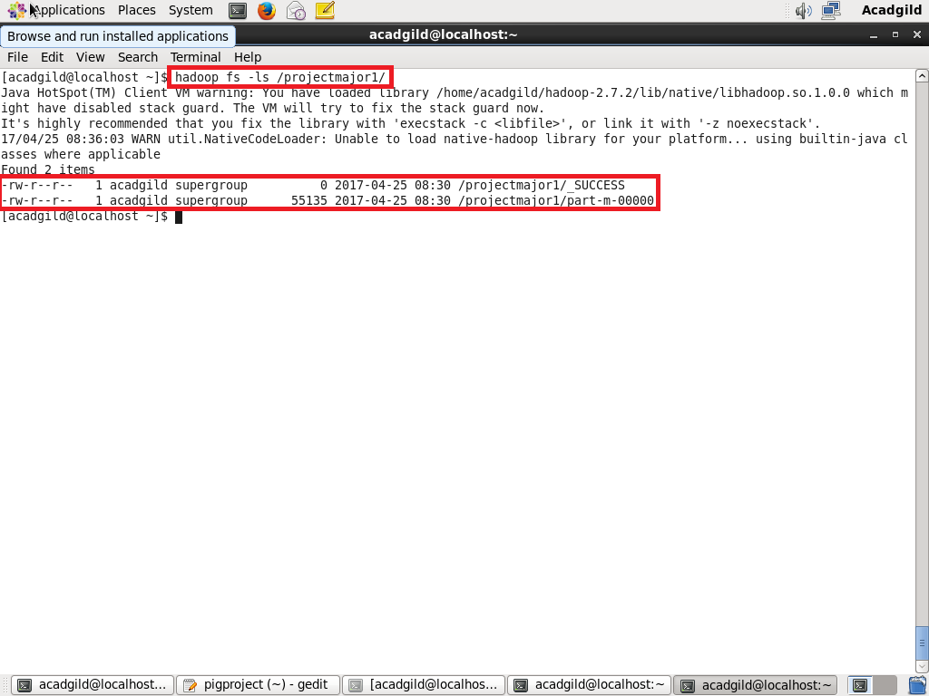

Displaying the contents of the part-m-00000 file using cat command-

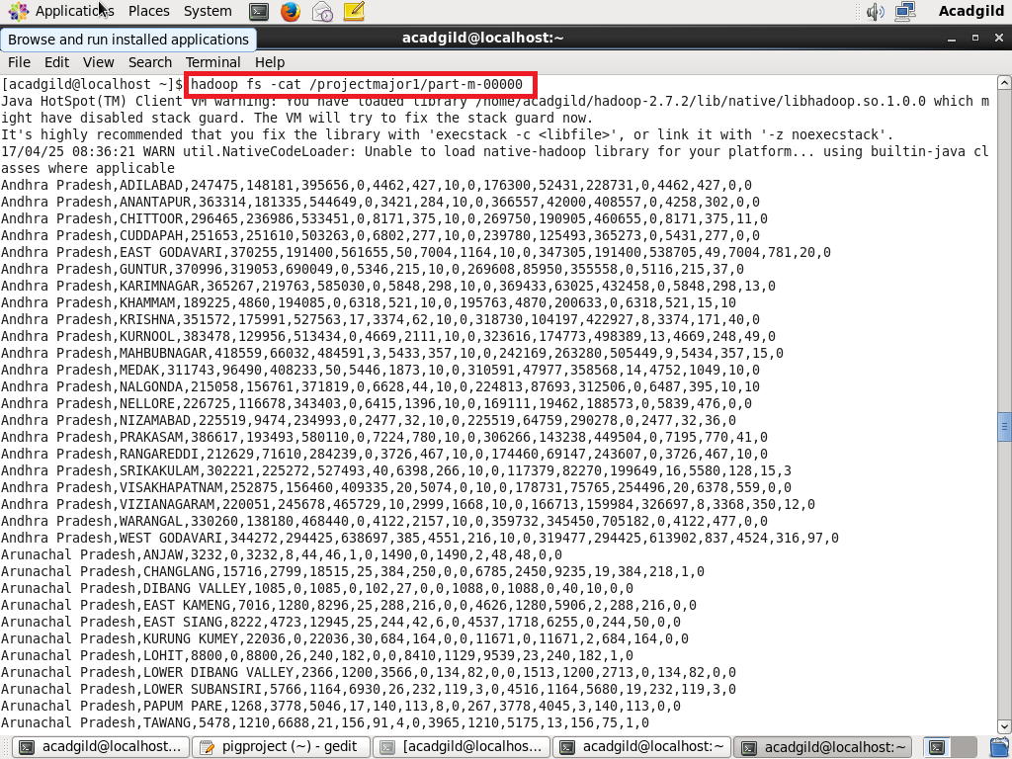

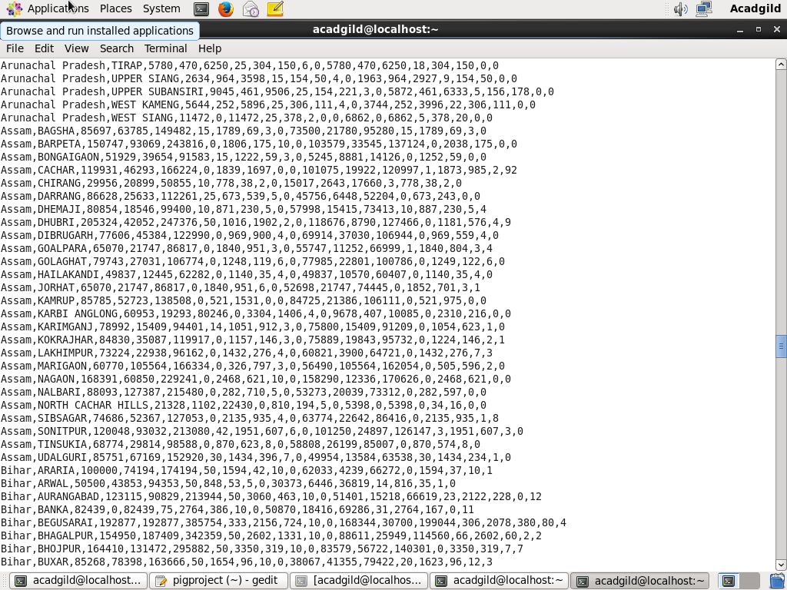

**Problem statement**

1. Find out the districts who achieved 100 percent objective in BPL cards Export the results to mysql using sqoop

**Solution-**

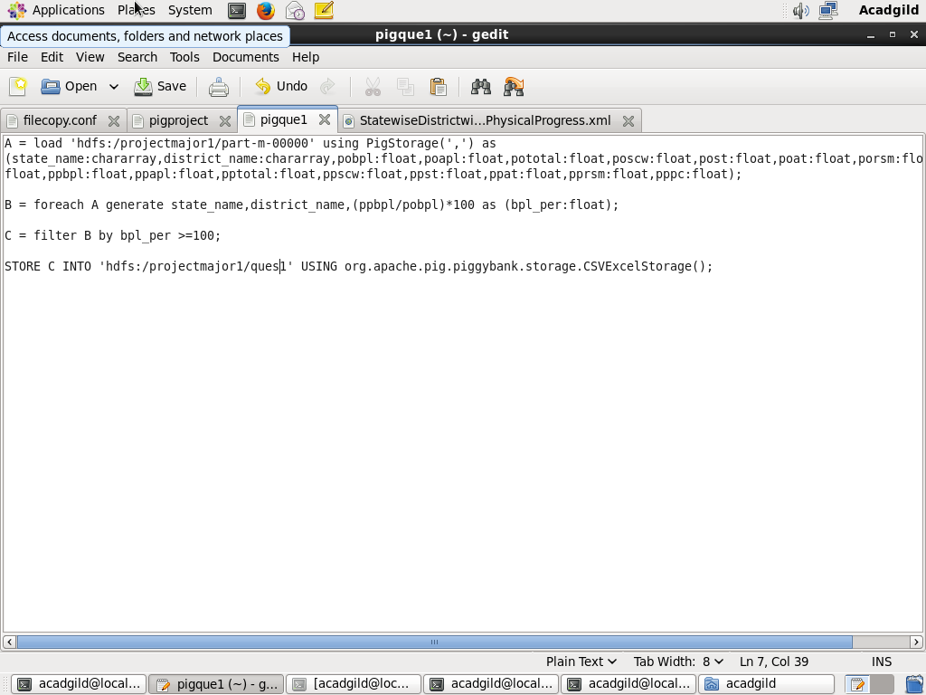

**# We have loaded the data and calculated the percentage.**

**# filtering the results where percentage is greater than or equal to 100.**

**# Generating the required columns and storing the result.**

**Running Pig Script-**

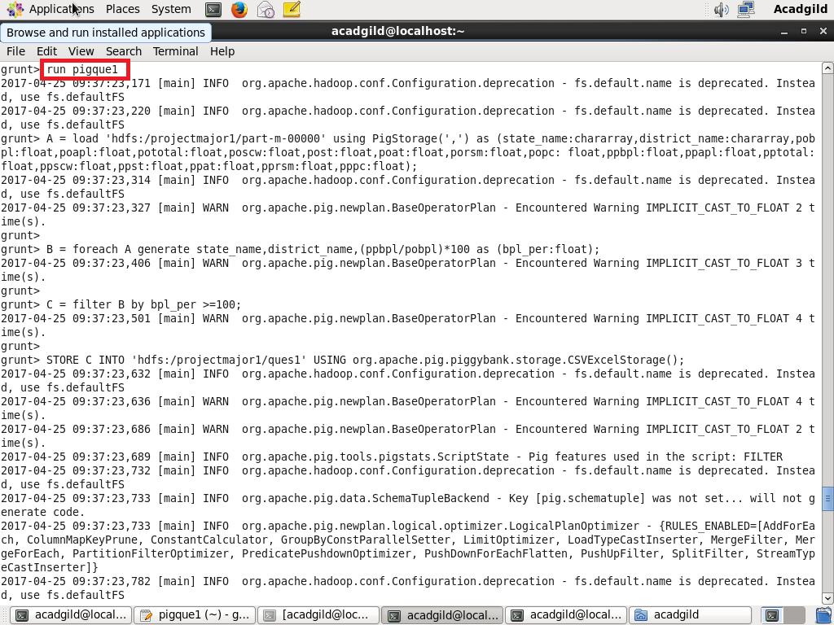

**Pig Script successfull execution-**

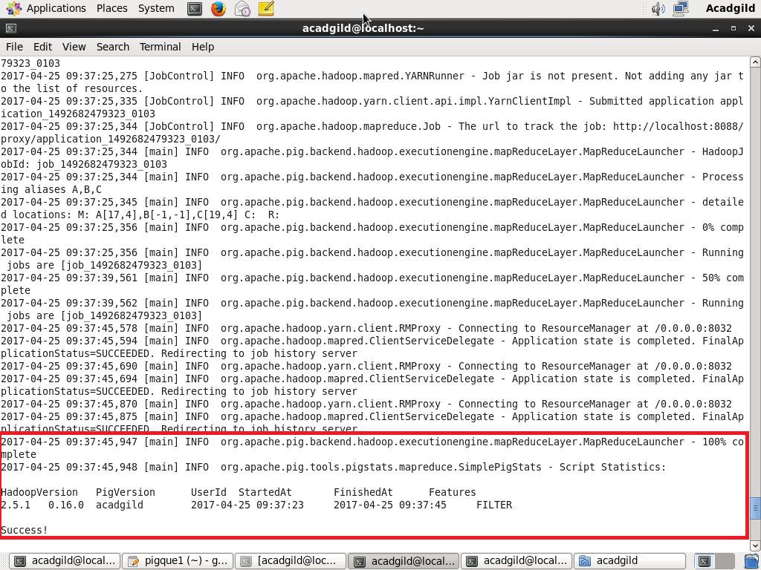**d:**

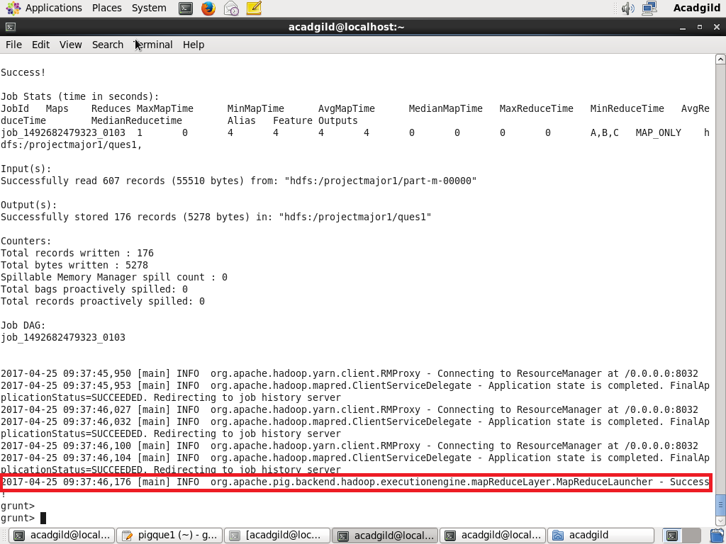

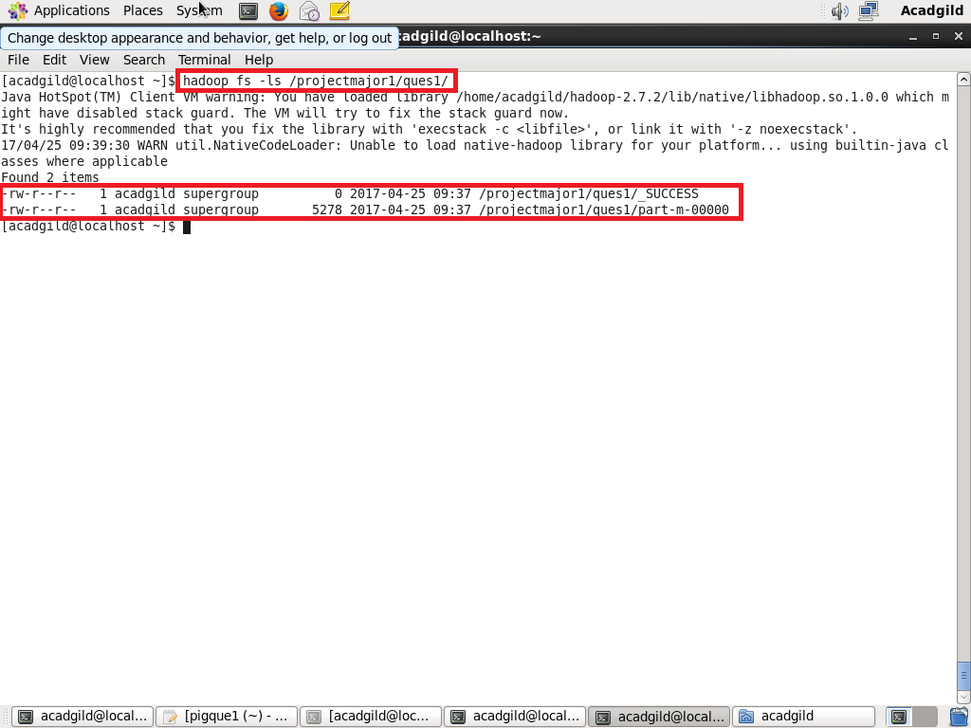

Displaying the contents of file using cat command-

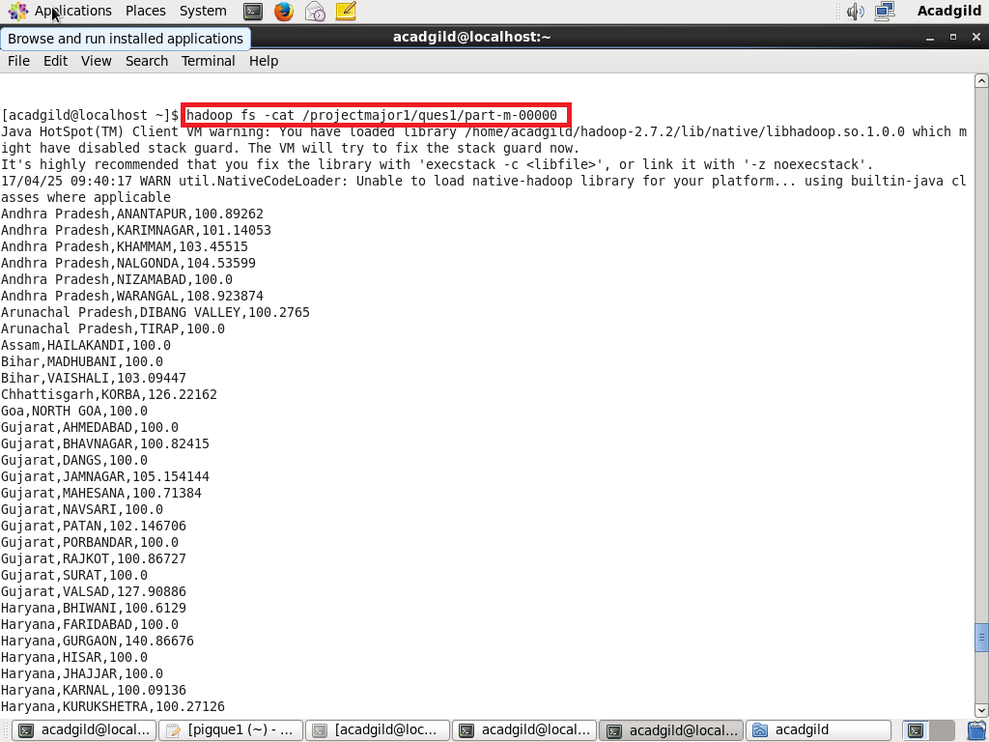

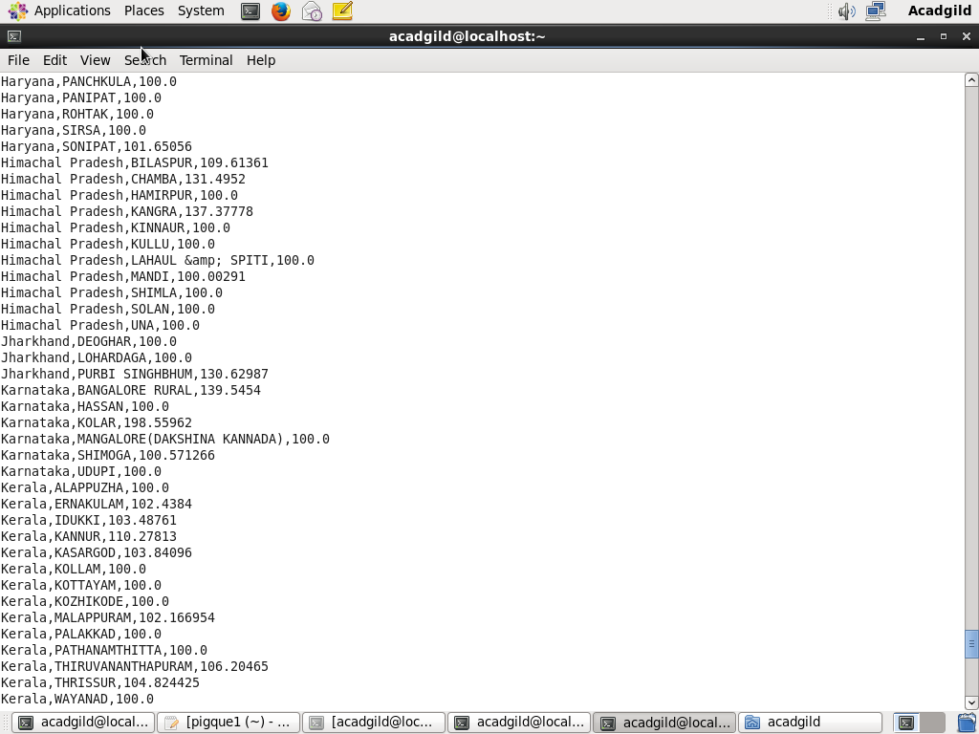

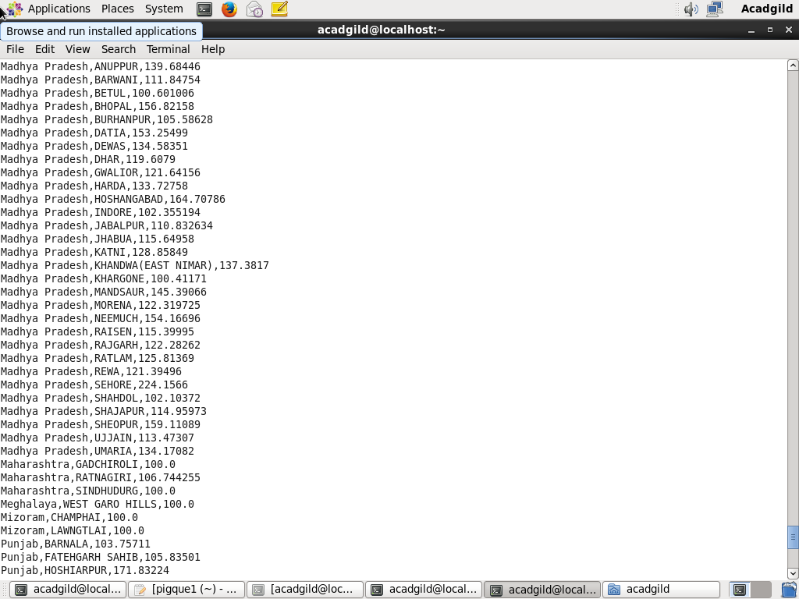

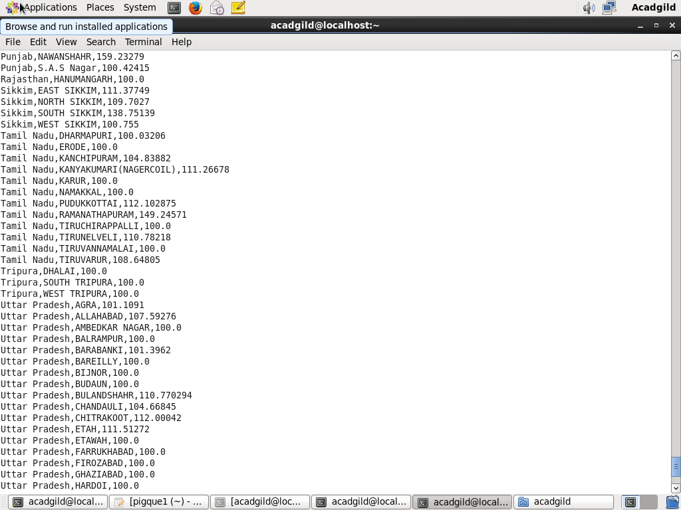

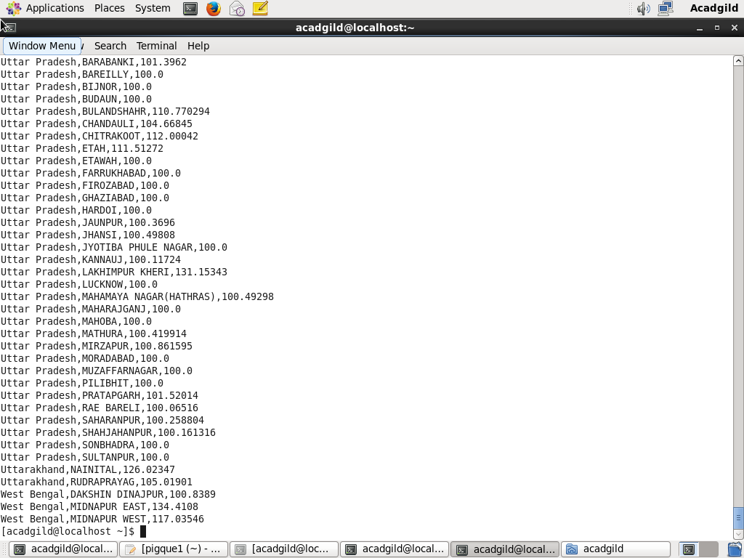

**Creating Mysql table-**

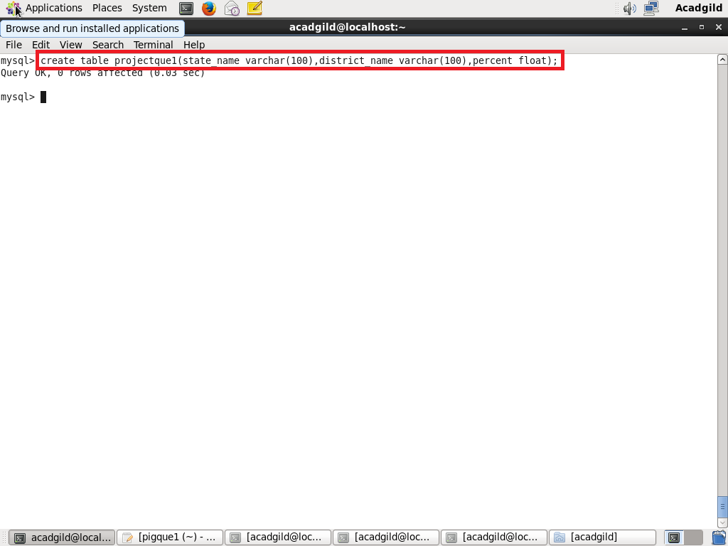

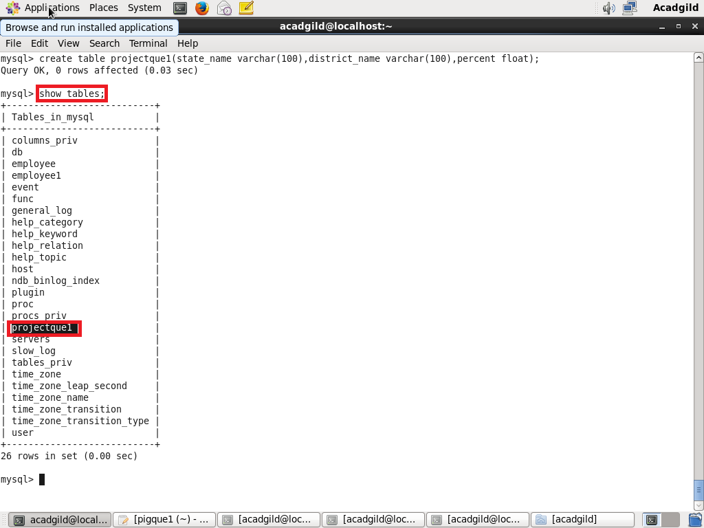

**Exporting data to mysql table using scoop-**

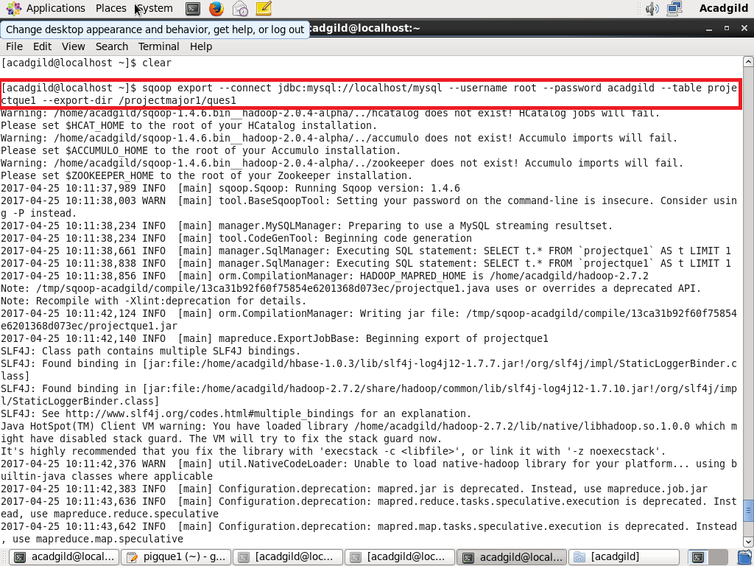

**Data successfully exported-**

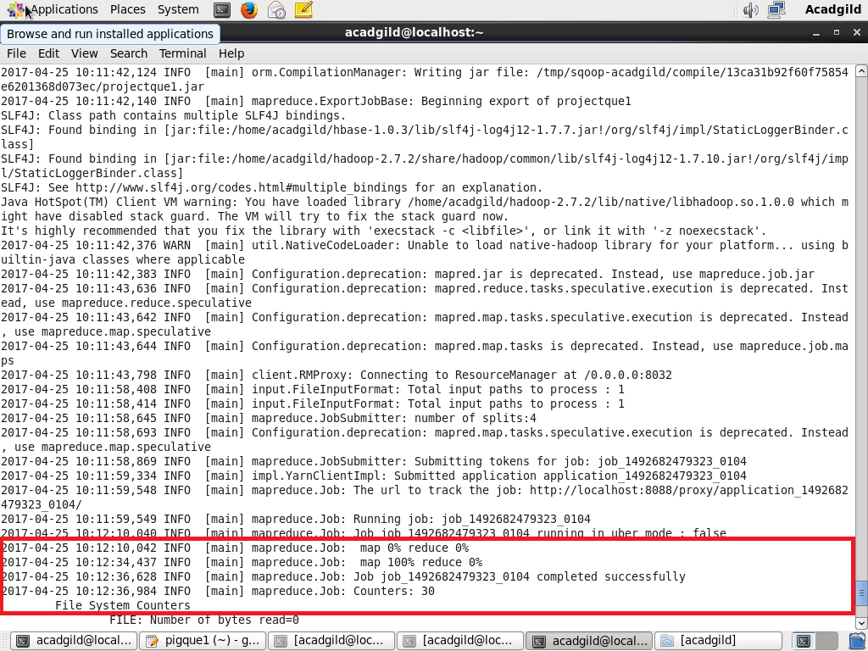

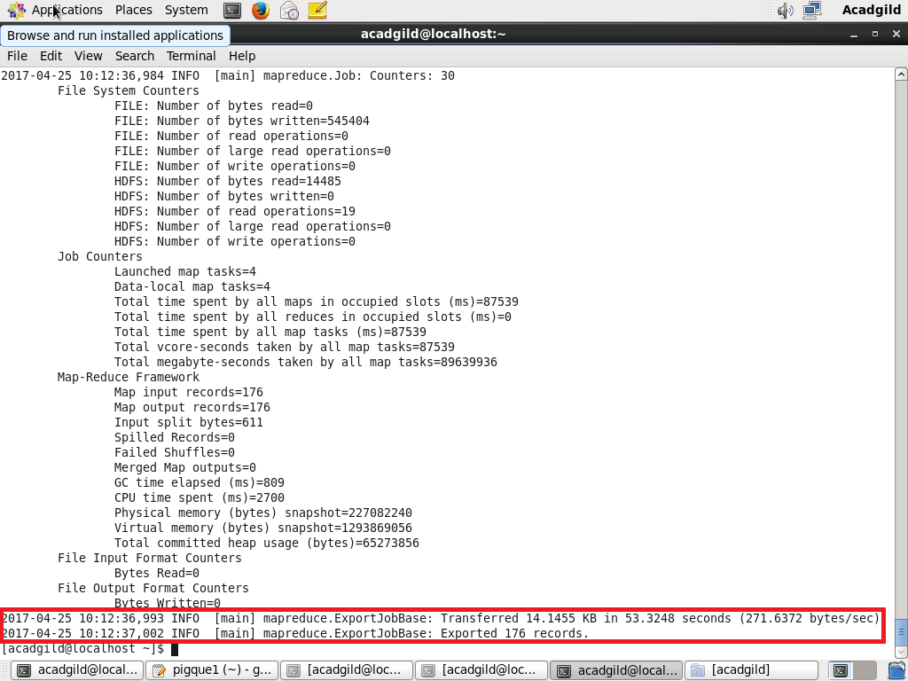

**Displaying the records of the table-**

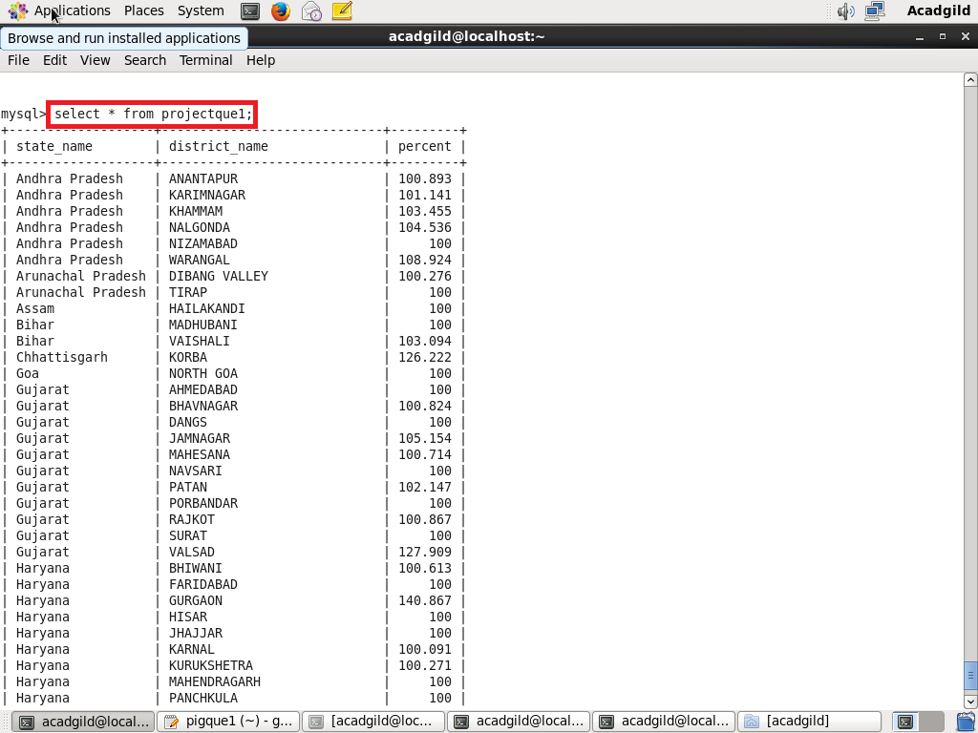

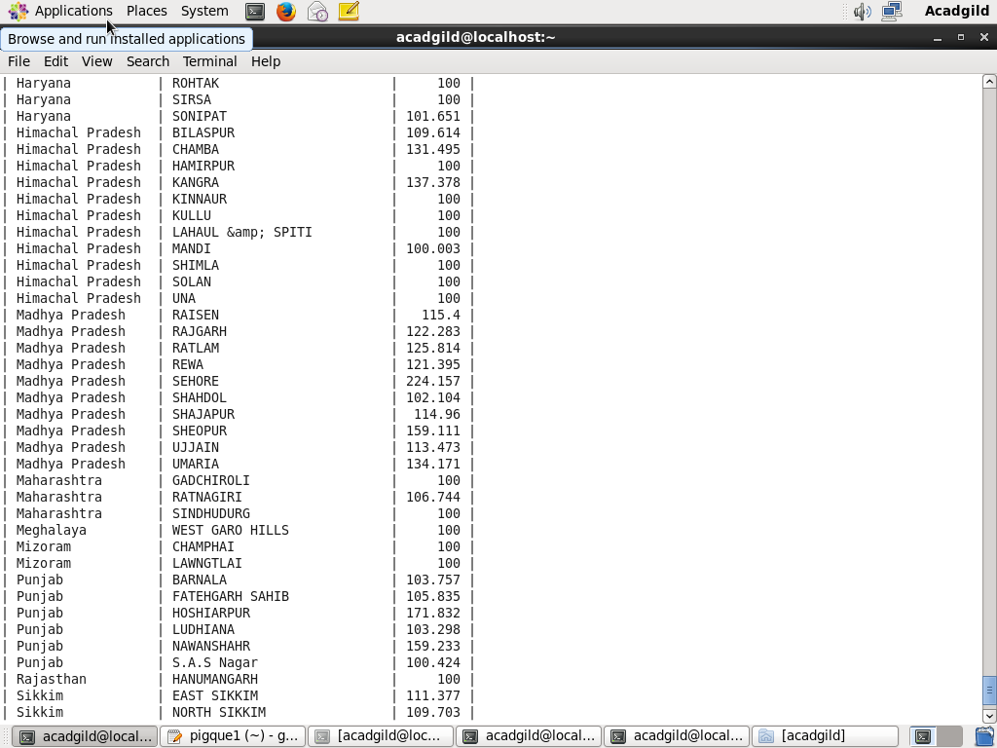

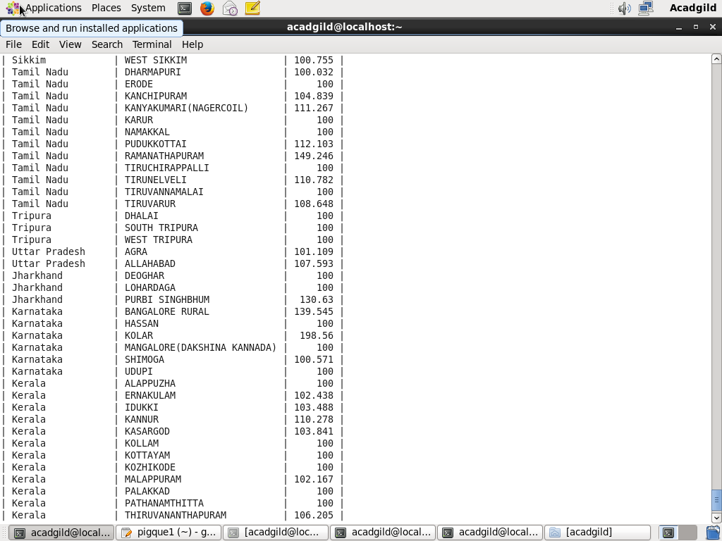

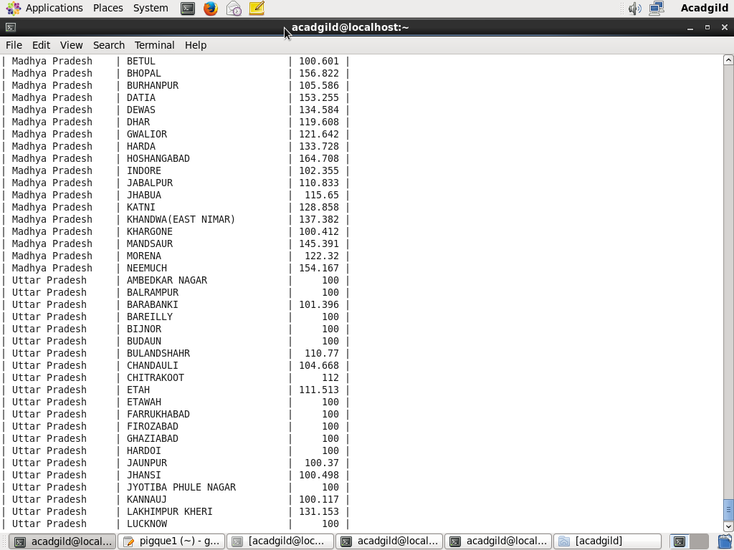

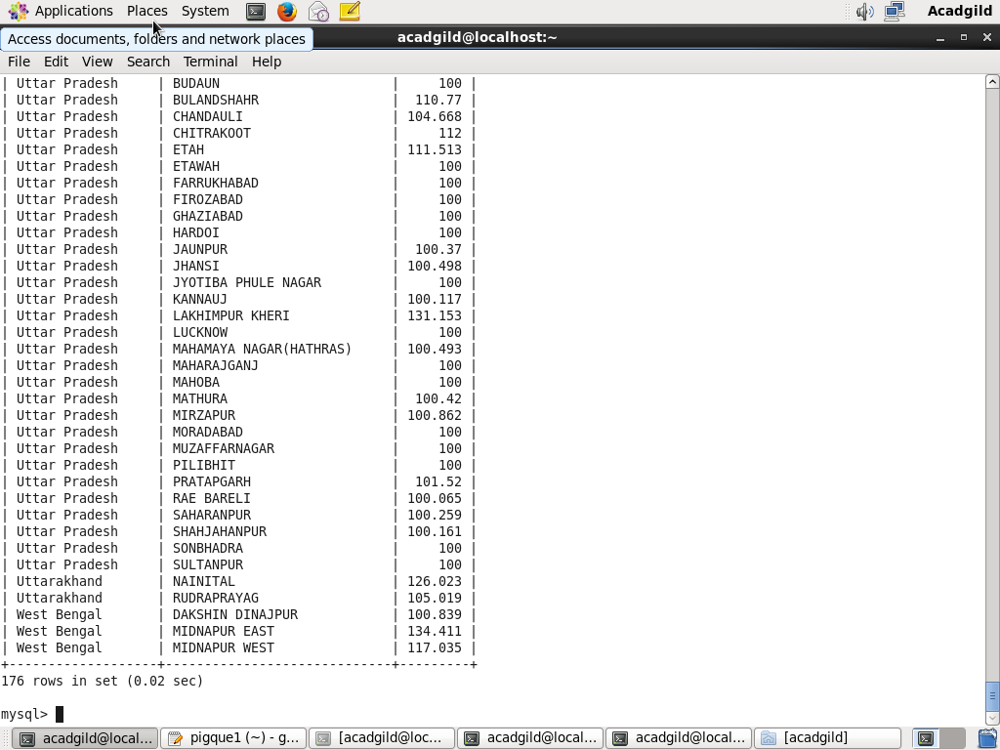

***Total 176 records have been exported.***

2. **Write a Pig UDF to filter the districts which have reached 80% of objectives of BPL cards. Export the results to MySQL using Sqoop.**

**Solution-**

**UDF program in java-**

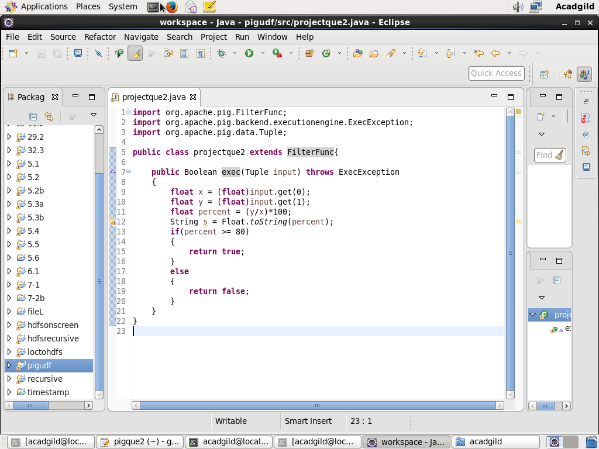

**Creating the jar & registering-**

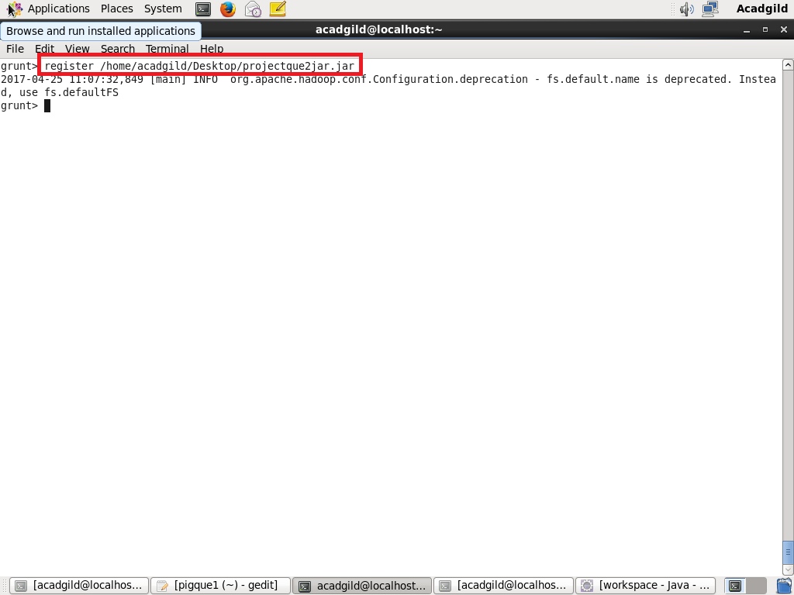

**Pig Script to execute UDF-**

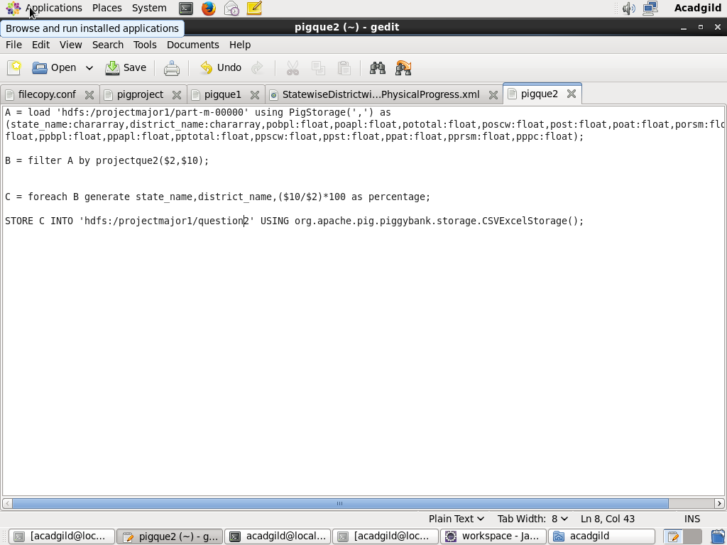

**# We have loaded the dataset.**

**# Executing the UDF.**

**# generating the required columns and storing the result.**

**Executing Pig Script-**

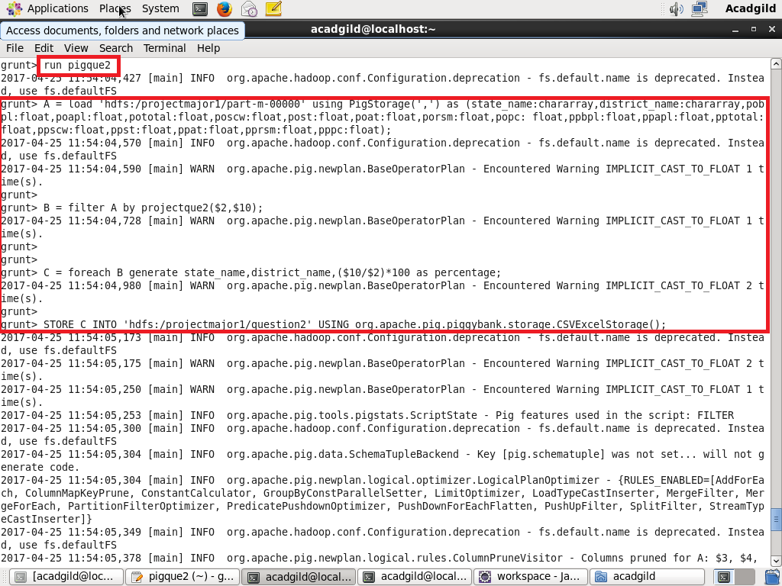

**Pig Script Successfully Executed-**

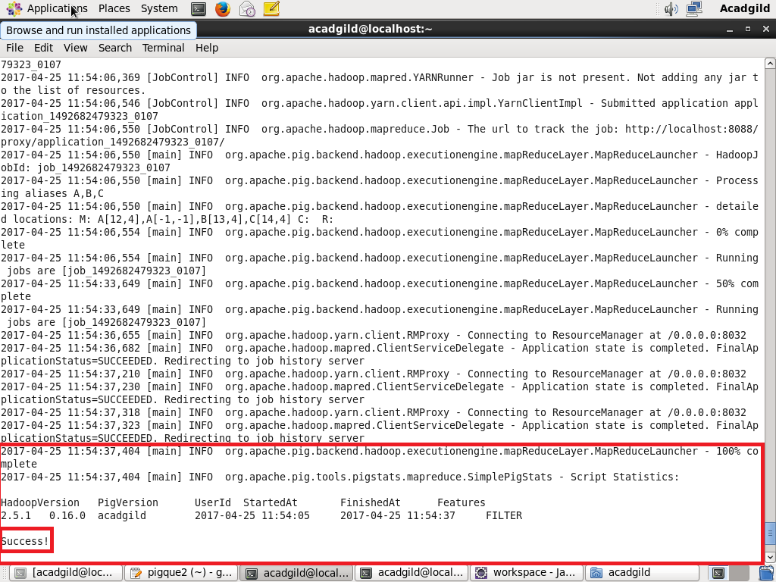

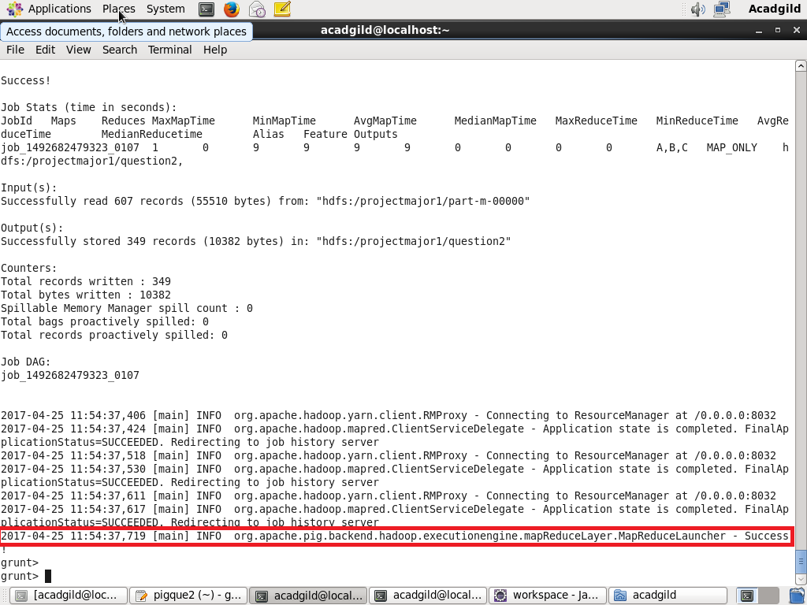

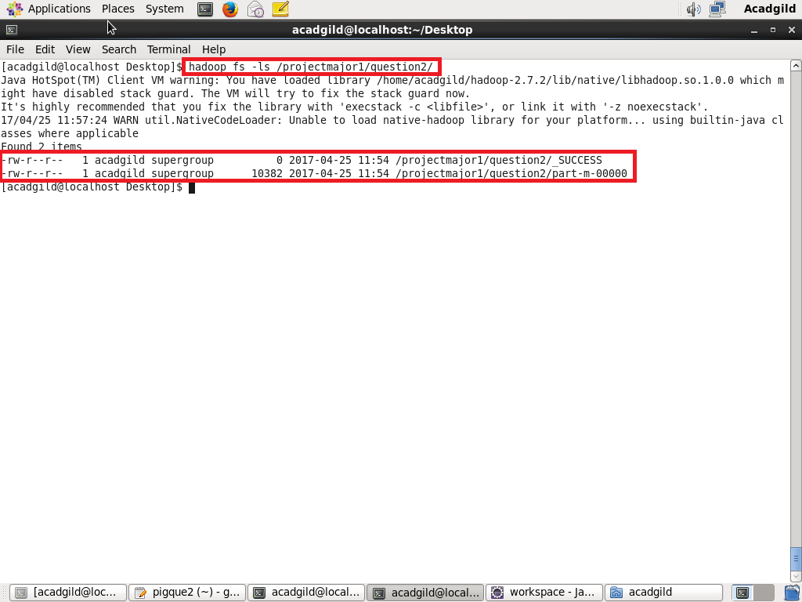

**The part-m-00000 file confirms that the pig script has executed successfully.**

**Displaying the contents of file using cat command-**

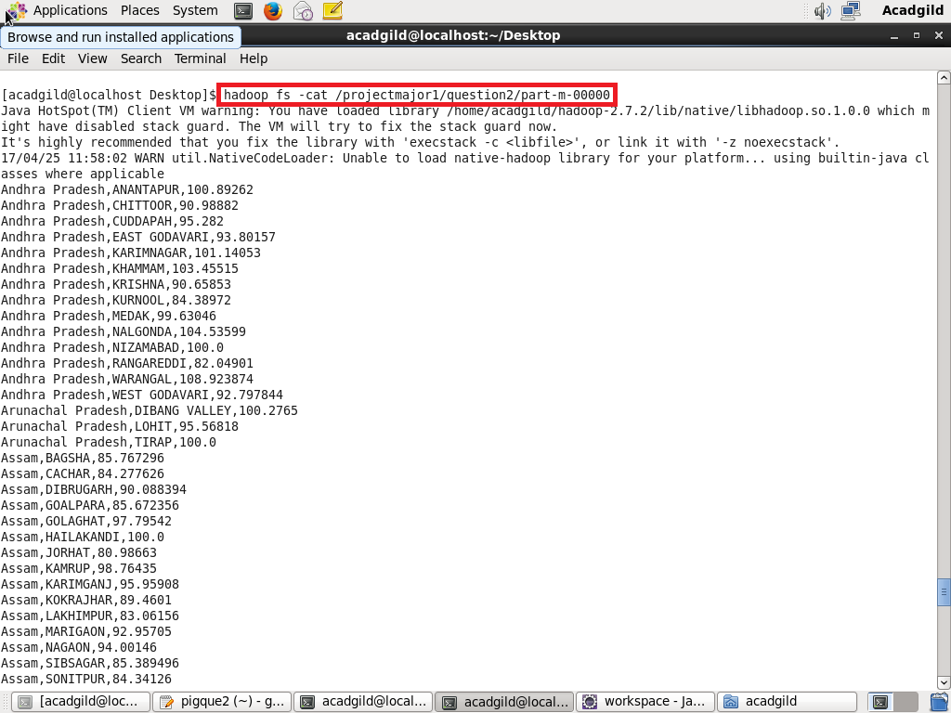

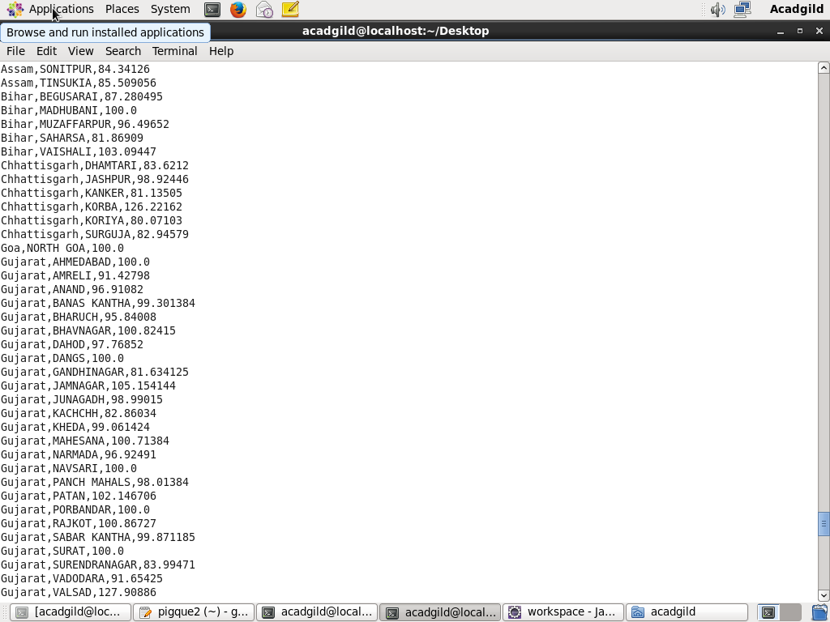

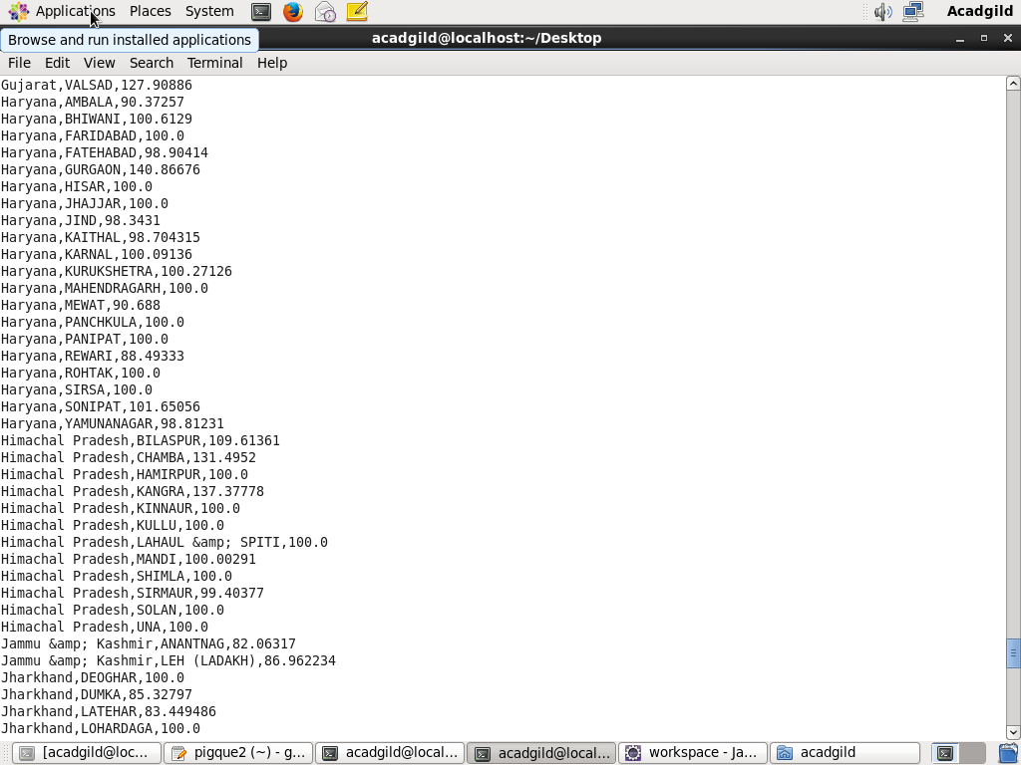

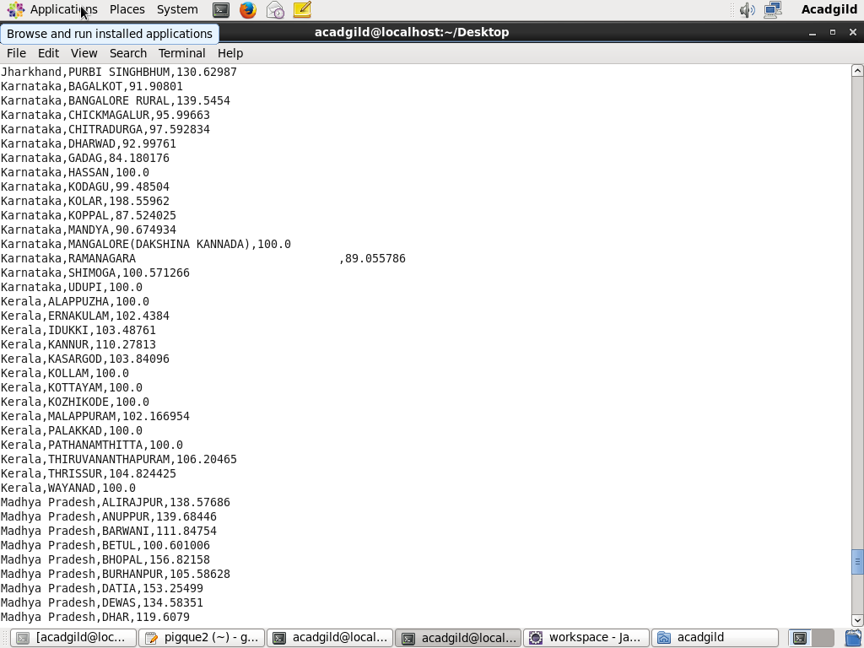

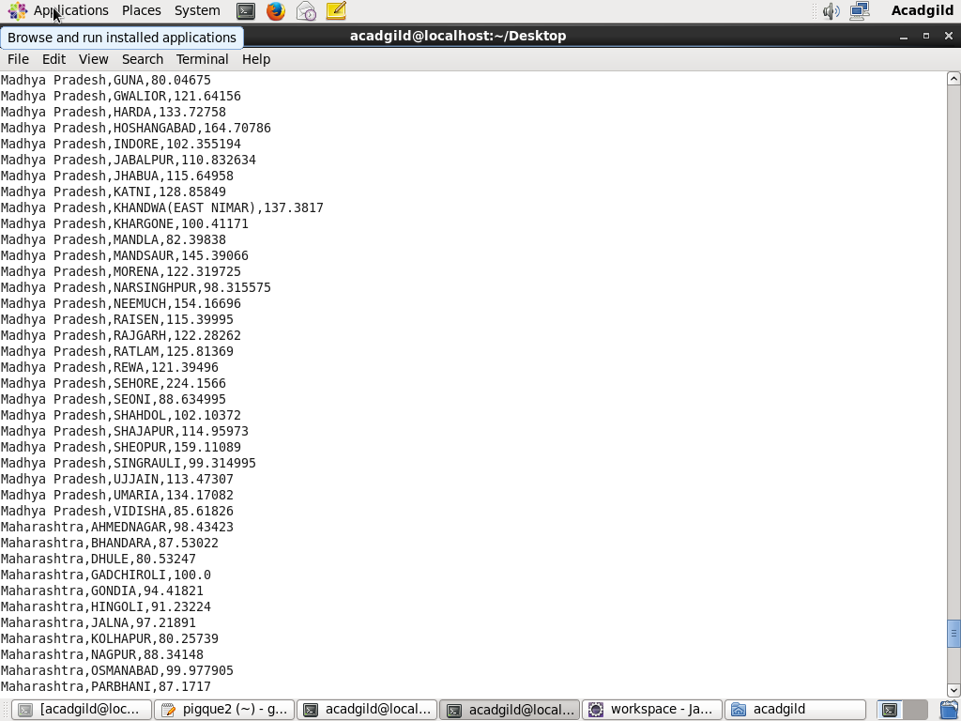

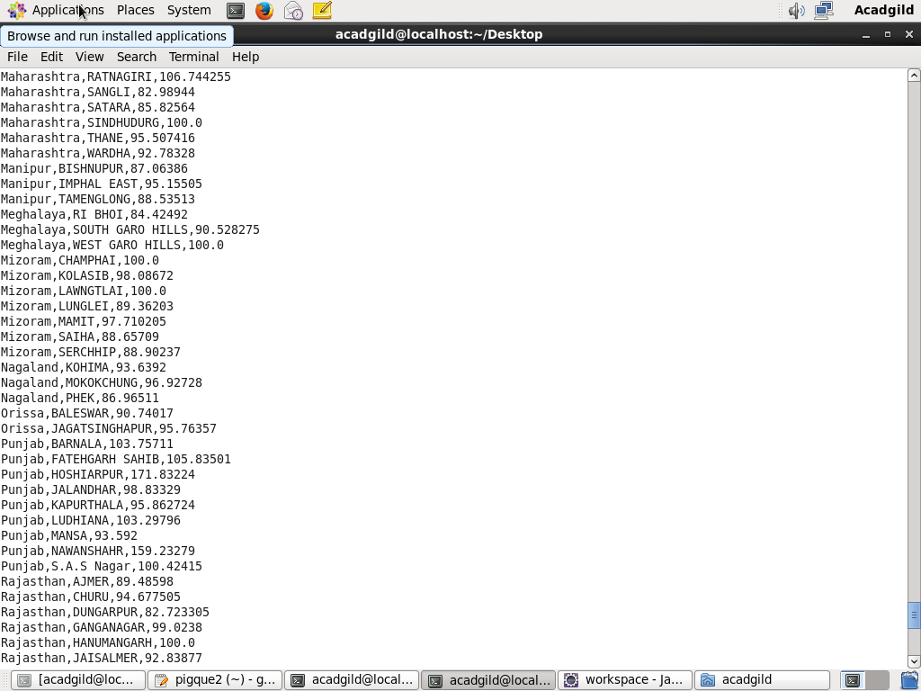

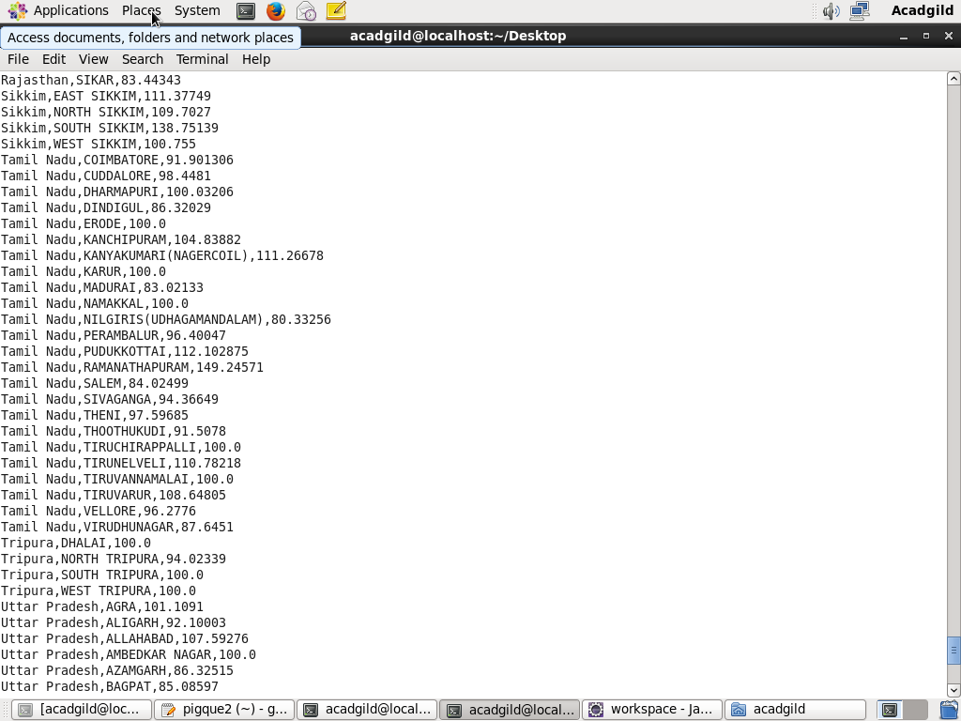

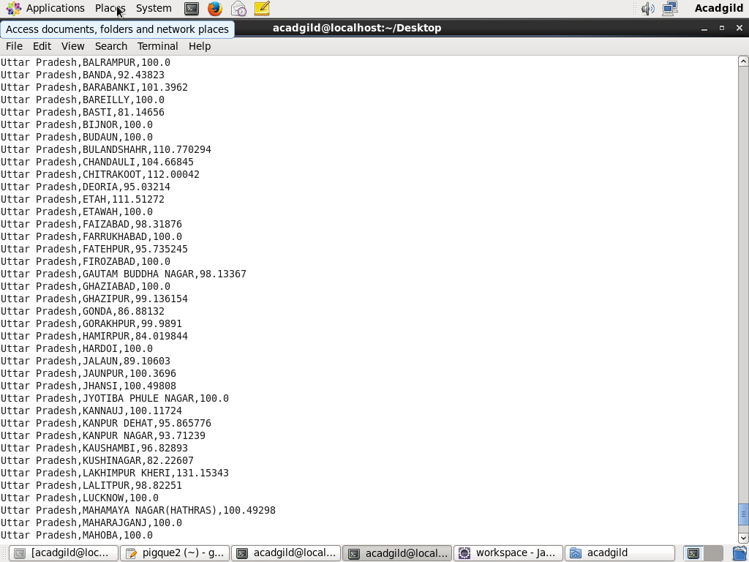

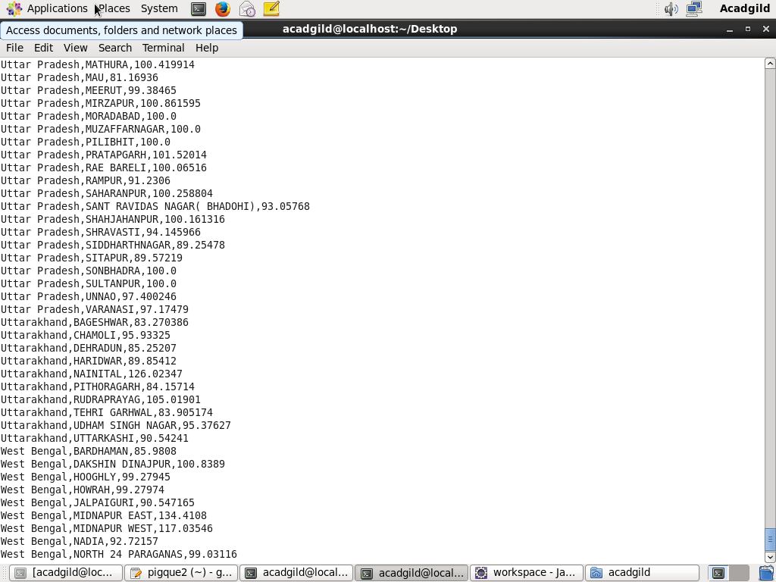

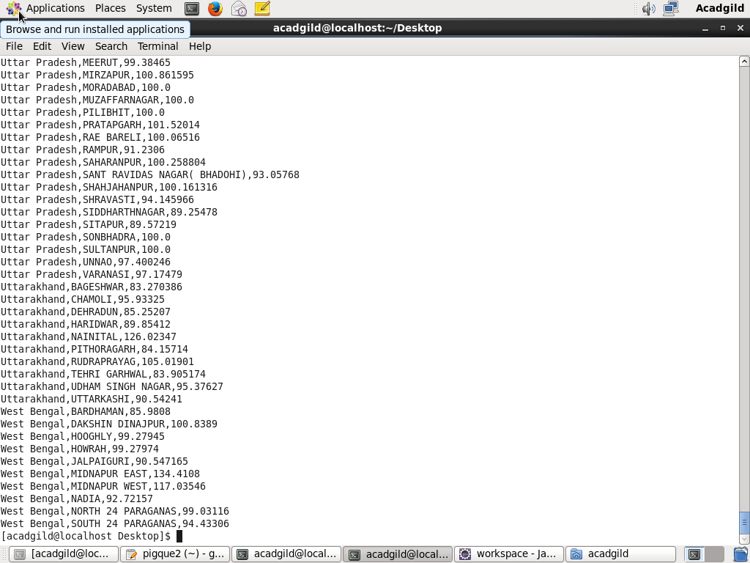

**Creating Mysql table-**

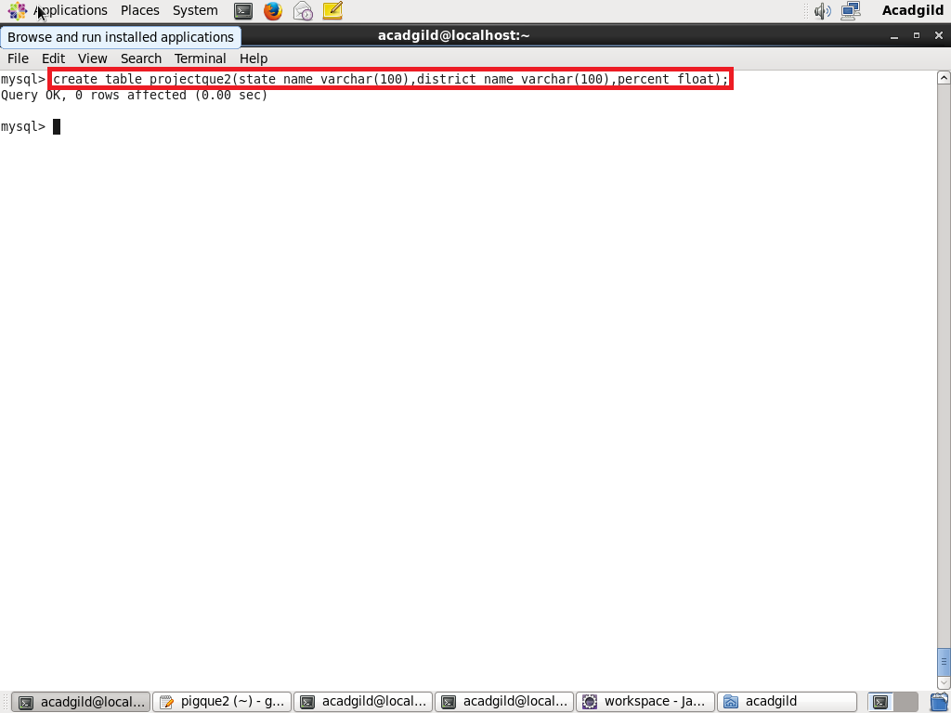

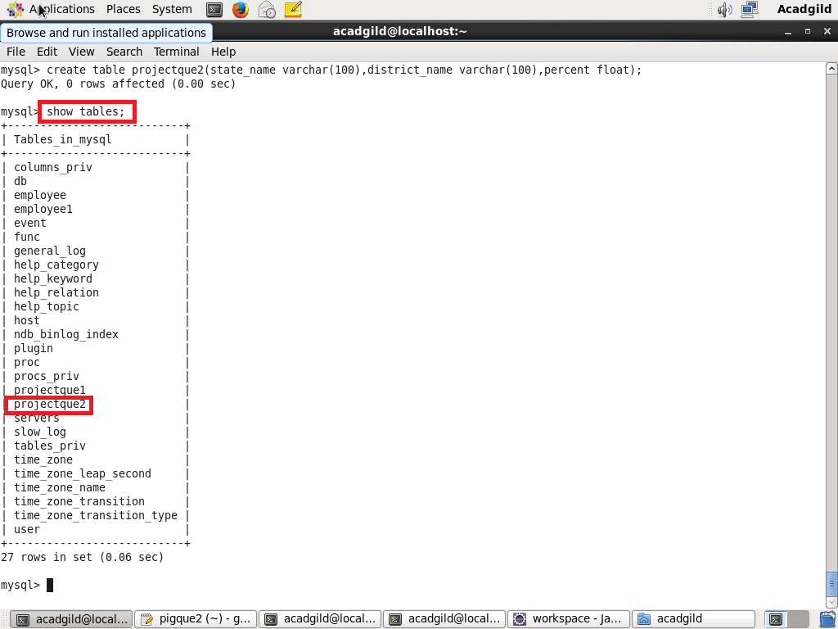

**Exporting data to mysql table using scoop-**

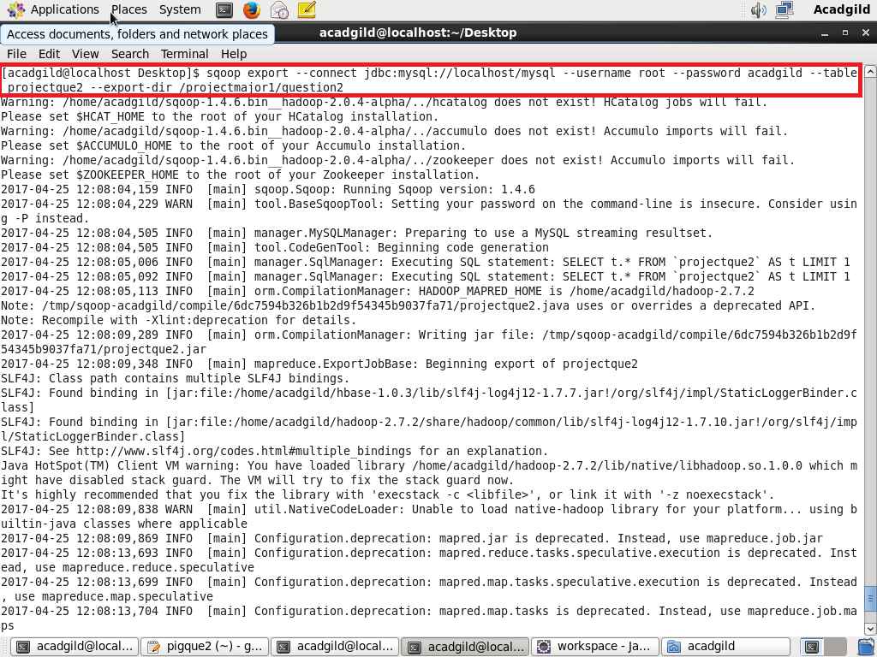

**Data successfully exported**

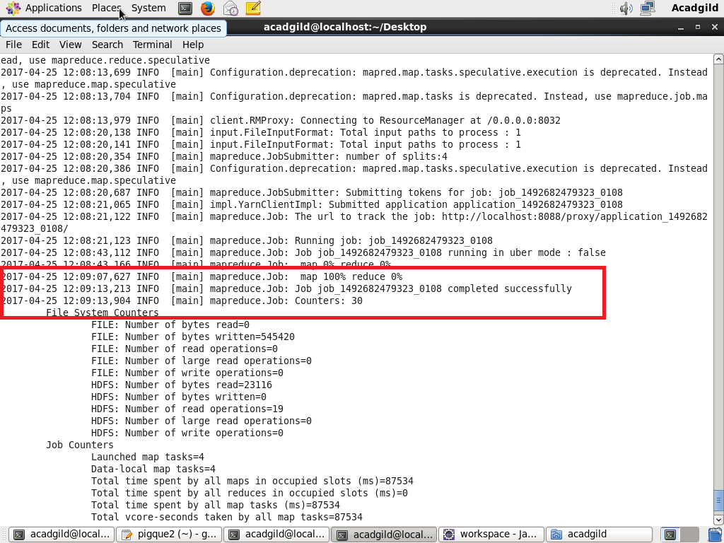

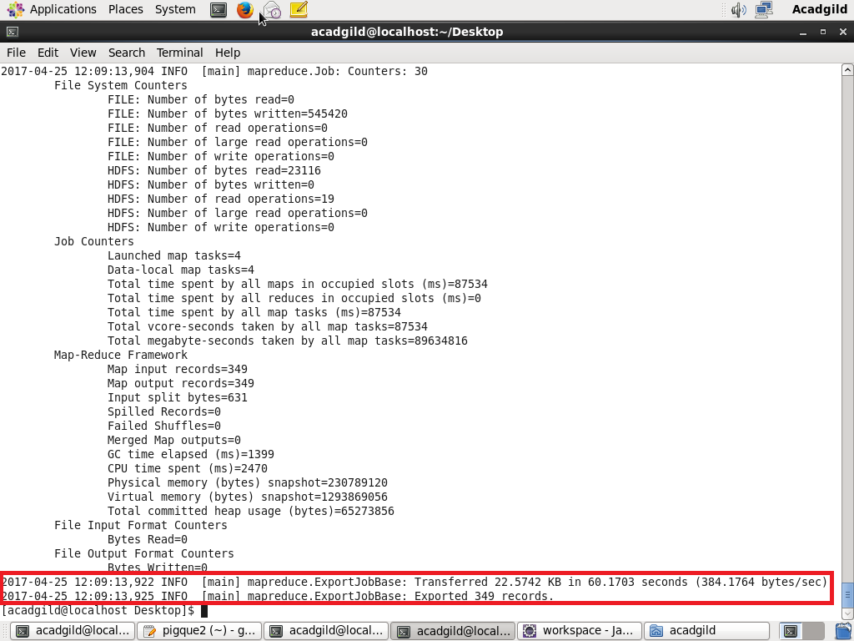

**Displaying the records of the table-**

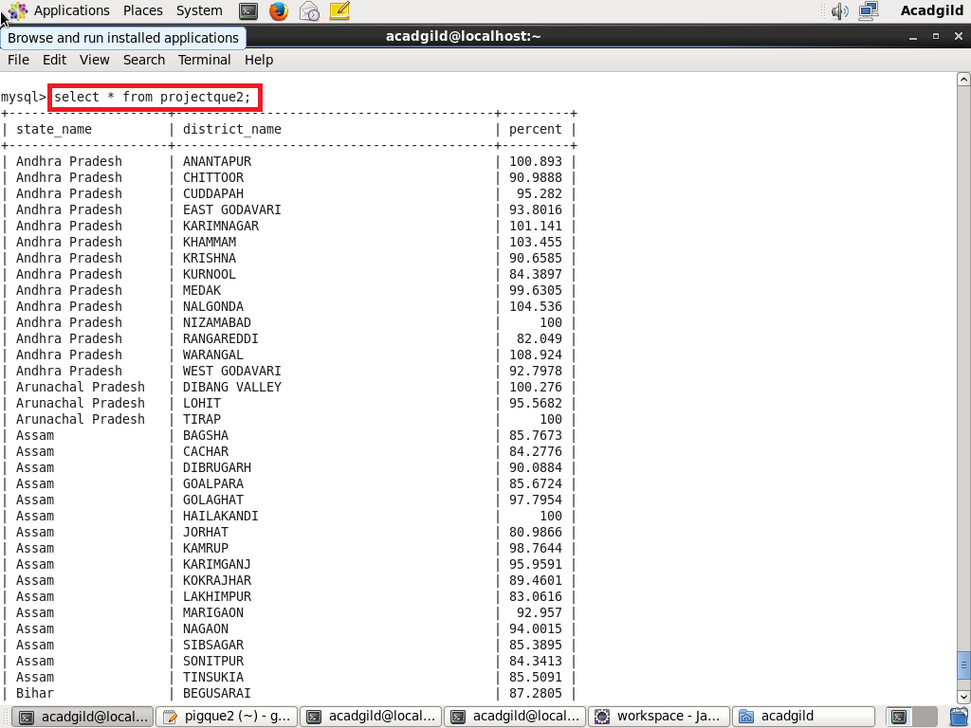

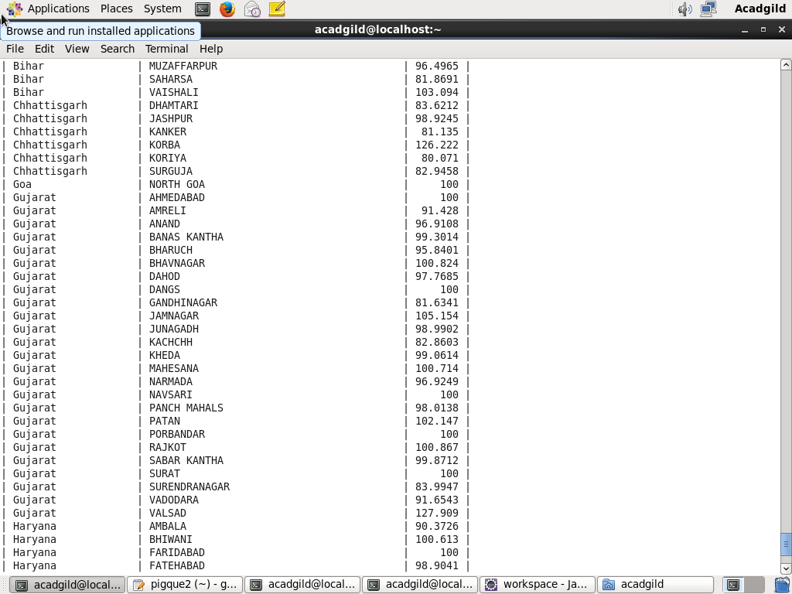

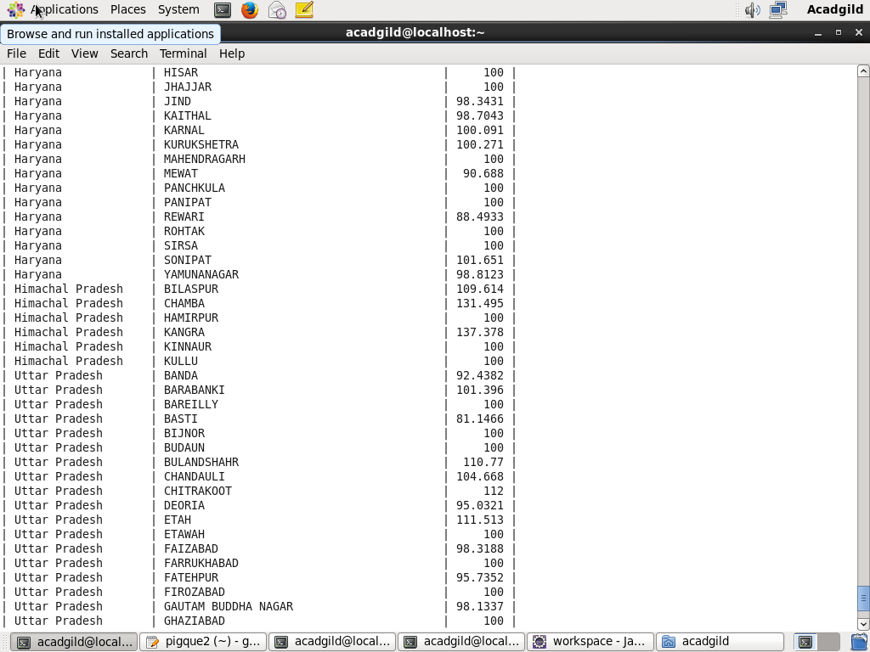

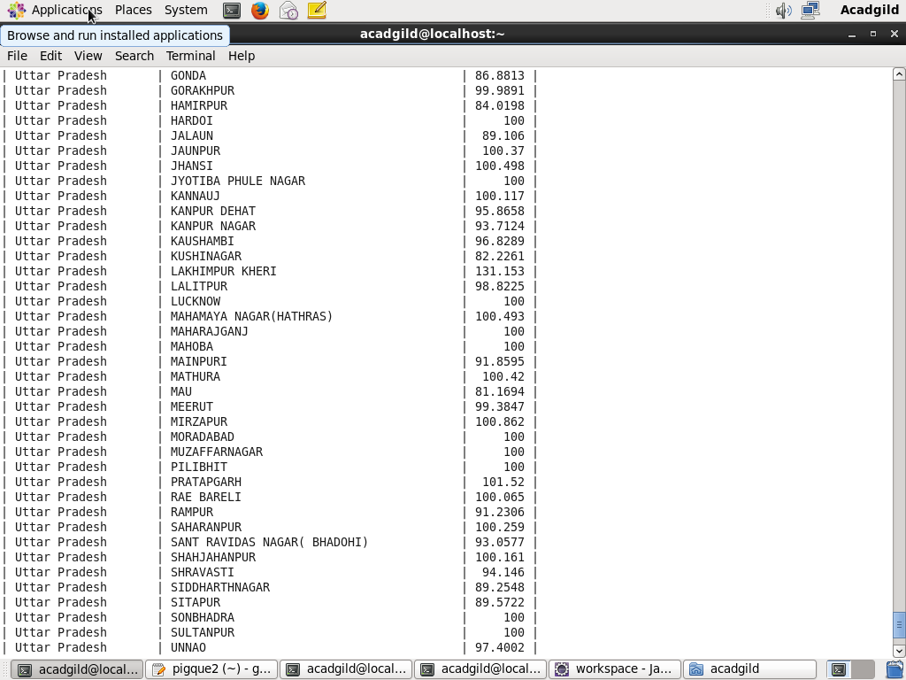

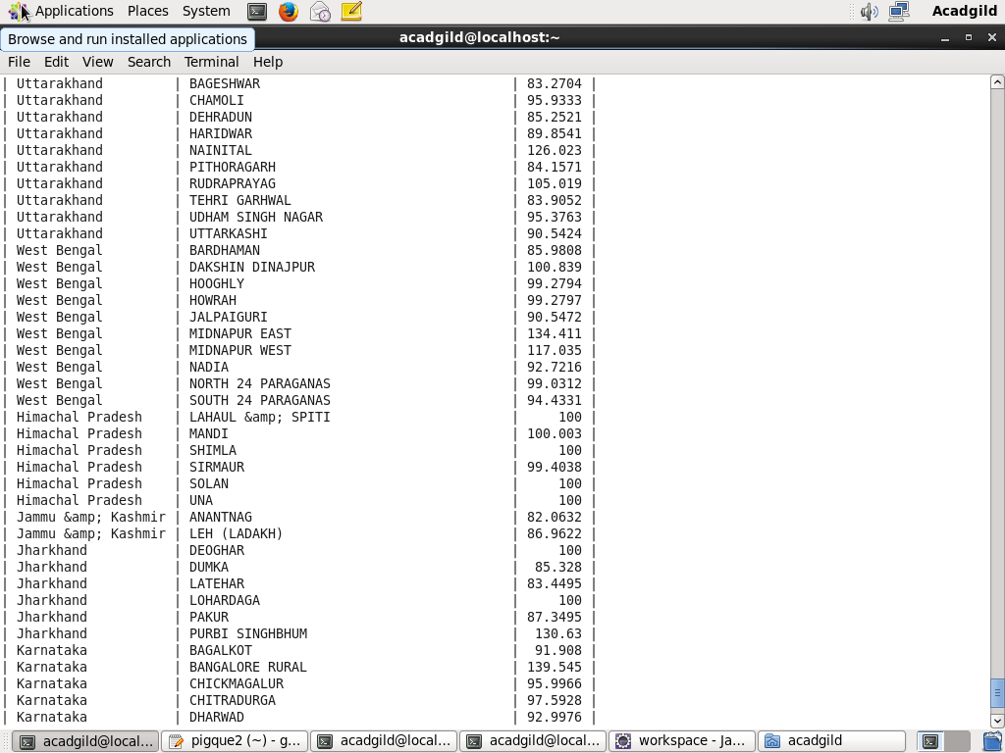

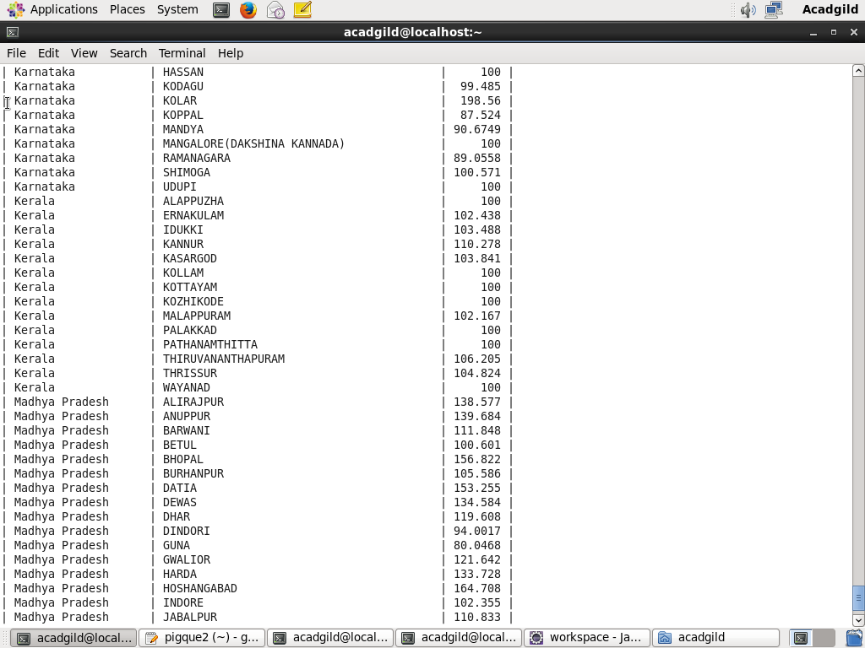

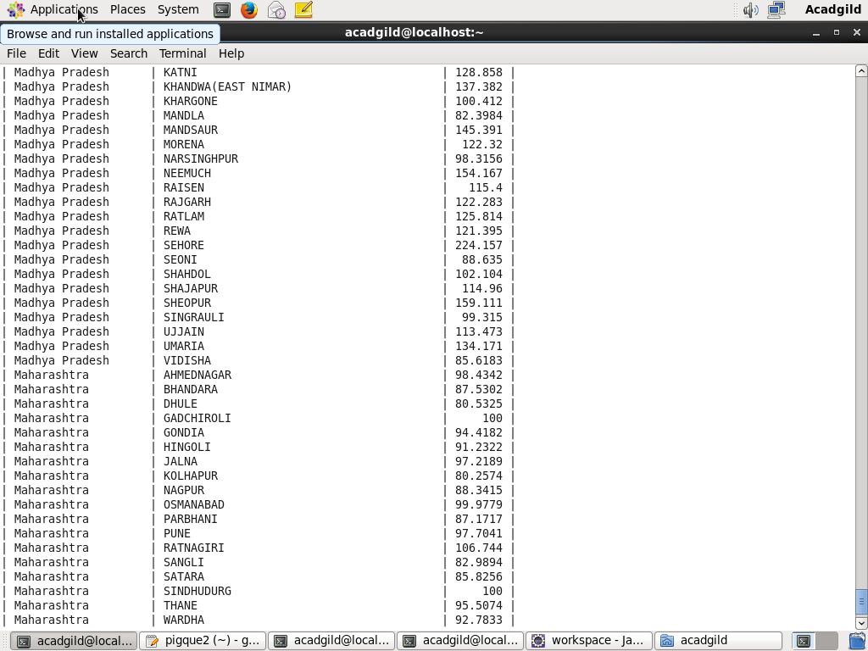

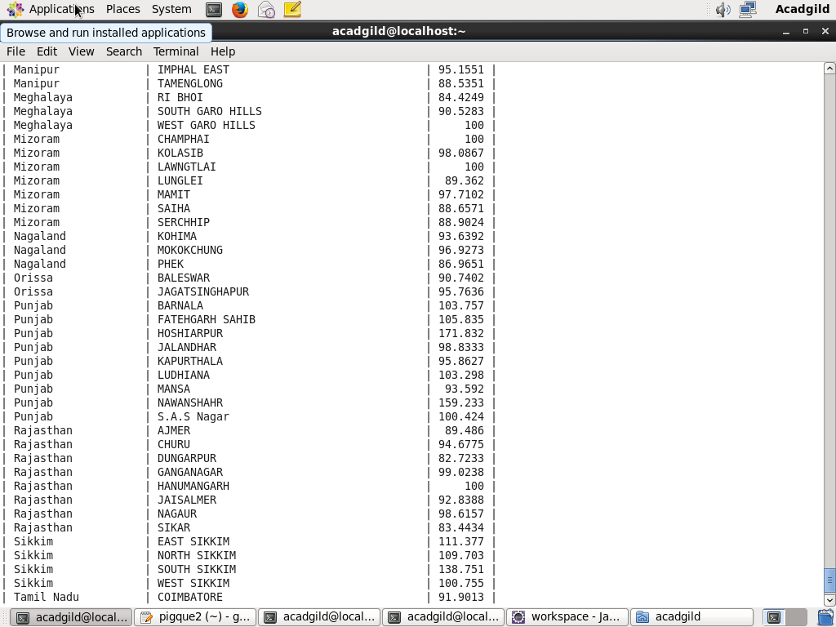

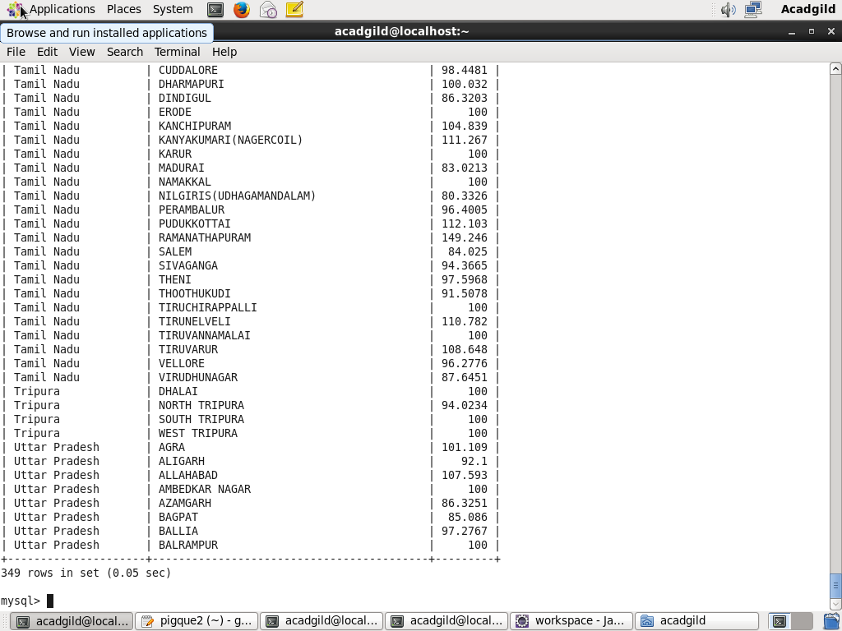

**Total 349 records have been exported.**

THANKS